**Visualizing Gerrymandering:**

**Efficiency Gap Analysis of the 2016 House of Representatives Election Results**

Carlos Sathler

I590 – Data Visualization

October 24, 2017

# Introduction

Gerrymandering is “a practice intended to establish a political advantage for a particular party or group by manipulating [district boundaries](https://en.wikipedia.org/wiki/Boundary_delimitation)”.[1] According to the Brennan Center for Justice, there are 3 ongoing cases of gerrymandering being disputed in court.[2] One of them, *Gill v. Whitford*, has reached the US Supreme Court. The plaintiffs contend the Wisconsin Legislature has hindered their First and Fourteenth Amendment rights by favoring the republican part in the way the legislature drew district lines after the census of 2010. Gerrymandering is a spurious political practice because it has the potential to silence a political party and make its political views and proposals inconsequential, threatening therefore the very fabric of our democracy.

An easy way to explain gerrymandering is illustrated in Figure 1 below.[3]

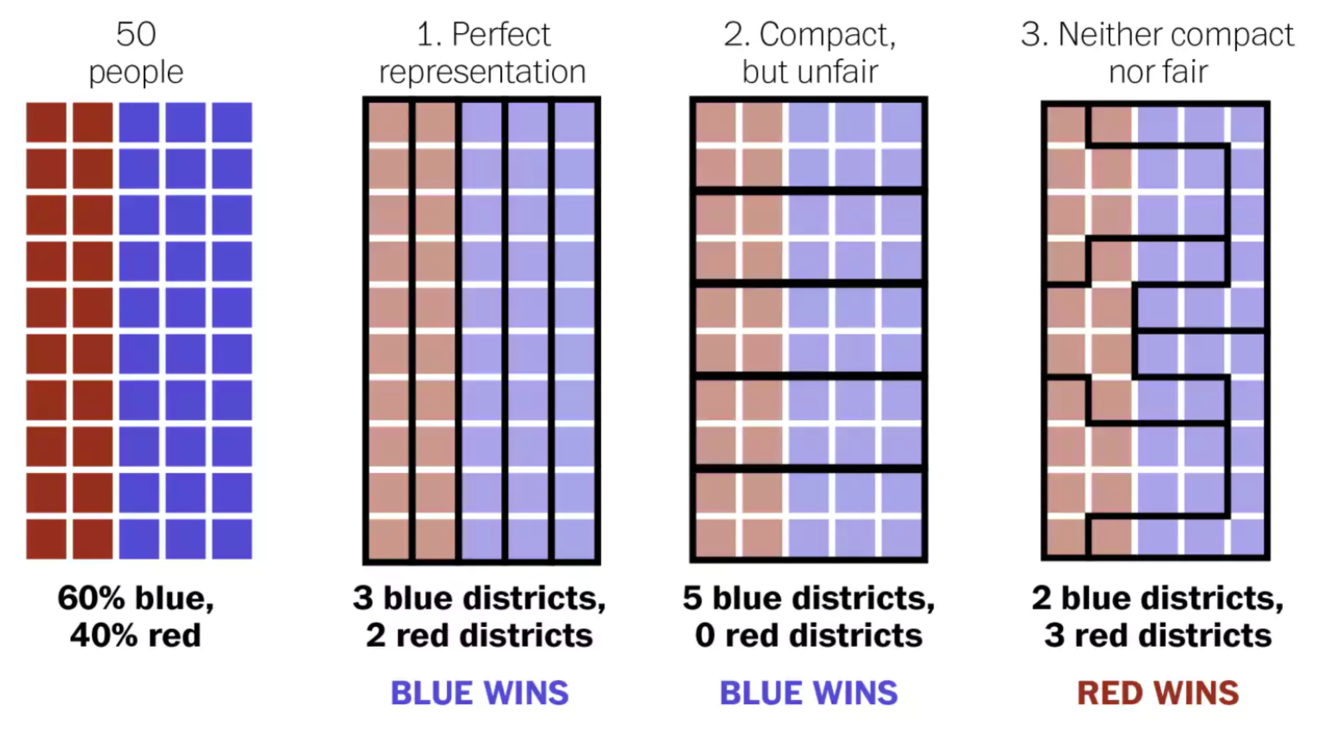

Figure 1 – The best explanation of gerrymandering you will ever see.2

The leftmost picture in Figure 1 represents a population of 50 people in a hypothetical rectangular state. Imagine this state can elect 5 representatives to the US House of Representatives, each representing 10 people. Since the proportion of red and blue voters is 2:3, a perfectly fair election would elect 2 representatives of the “red” party and 3 representatives of the “blue” party to the House of Representatives.

The grouping of voters by boundaries inside a state is called “districting”. Districts are redefined every 10 years based on census numbers, so that each district have the same population. Each electoral district in a congressional election will elect a single representative.[4] On Figure 1, the second picture on the left shows district boundaries achieving ideal representation; the third and fourth show examples of districting that favor one or the other party, and are both unfair. The third illustration is unfair to “red” voters and the fourth is unfair to “blue” voters.

The primary motivation for our project is the identification of states where certain parties are blatantly under/over represented due to unfair districting. We will primarily use the concept of “efficiency gap” for our analysis. This concept was conceived for the specific purpose of assessing gerrymandering[5],[6] and is being used in the current Wisconsin gerrymandering case *Gill v. Whitford*.[7],[8]

Central to the “efficiency gap” metric is another concept called “wasted vote”. A “wasted vote” is a vote that does not contribute to win an election. So all votes for a losing candidate are “wasted” in that sense, and all votes for a winning candidate in excess of the number of votes needed to win the election are also “wasted”. The efficiency gap is calculated as “the difference between the two parties' wasted votes, divided by the total number of votes”.[9] The metric therefore measures the percentage of votes that failed to contribute to place a party’s candidate on an electoral seat.

The issue of vote “efficiency” and “waste” can be well illustrated by the 2016 congressional election results shown in Figure 2. According to the Wikipedia infobox for the United States House of Representative Elections, 20169 Republicans received 49.1% of the popular votes while Democrats received 48%. Yet Republicans won 241 seats while Democrats only won 194; *the Republican Party was able to convert 1% more votes into 24% more seats in the congress.*

# 

Figure 2

Section from United States House of Representative Elections, 2016 Wikipedia info box[10]

Our project hopes to deliver visualizations that provide insights into the connection between the imbalance portrayed in Figure 2 and gerrymandering, while using the efficiency gap metric as a tool to assess unfair districting. We spend considerable time contrasting efficiency gap numbers for different states. We hope that through impactful visualization that clearly highlights unfair representation in general, and gerrymandering in particular, we will raise awareness to existing districting issues, so that voters possibly become motivated to join by-partisan efforts to stop gerrymandering (such as FairVote[11]) thus contributing to a more fair electoral system and a stronger democracy.

# Overview of Existing Work on Gerrymandering

We identified many visualizations that explain gerrymandering with play data,[12],[13] including the one included herein as Figure 1. There are many visualizations on the web showing maps of districts with highly irregular boundaries that clearly indicate gerrymandering, but do not include any data analysis.12,[14],[15] The online game “The Redistricting Game”[16] is worth mentioning because it offers an excellent opportunity for regular citizens to understand how gerrymandering works. In the game players engage in districting a fictitious state to achieve political advantage.

In addition to the issue of wasted votes and unfair representation that we explore on our project, there are at least two other relevant issues associated with gerrymandering. One of them is well explained in two videos featuring Governor Arnold Schwarzenegger.[17],[18] Governor Schwarzenegger outlines how politicians engage in gerrymandering to perpetuate themselves in the US House of Representatives, regardless of their performance. We found visualization that corroborates Mr. Schwarzenegger assertion. According to OpenSecrets.org the US House of Representatives re-election rate in the period of 1964-2016 was seldom less than 85%.[19] Mr. Schwarzenegger created a “Crowdpac” to combat gerrymandering.[20]

The second issue that motivated our project is related to the possible impact of gerrymandering in the perceived growing polarization of our political system.19,[21],[22] Nate Silver’s visualization (Figure 3) is insightful.[23]

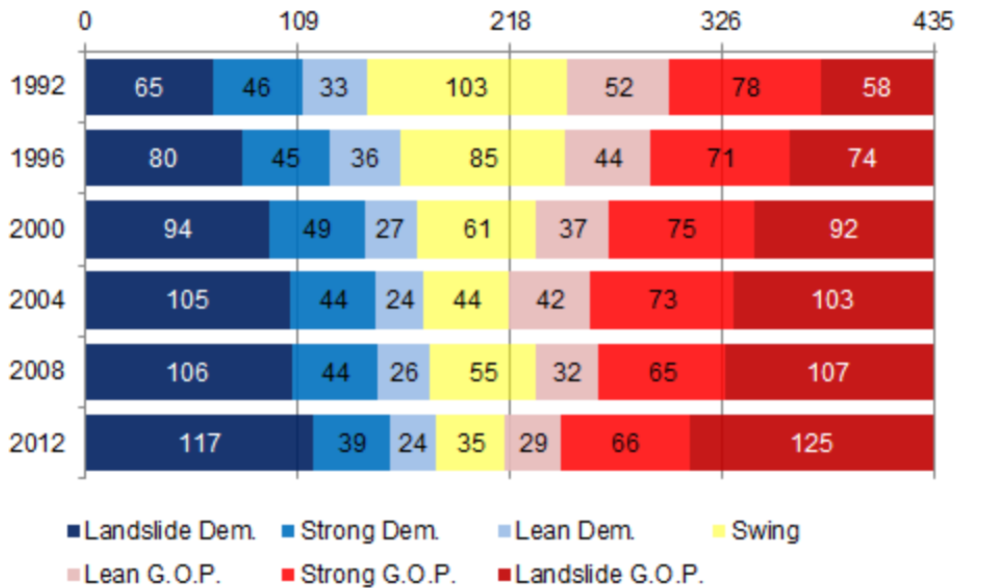

Figure 3

Nate Silver on the Increasing Polarization in our Elections

One possible way to approach the topic is the Cook Partisan Voting Index[24],[25] which measures “how strongly a United States [congressional district](https://en.wikipedia.org/wiki/Congressional_district) or [state](https://en.wikipedia.org/wiki/U.S._state" \o "U.S. state) leans toward the [Democratic](https://en.wikipedia.org/wiki/Democratic_Party_%28United_States%29) or [Republican](https://en.wikipedia.org/wiki/Republican_Party_%28United_States%29) Party, compared to the nation as a whole”.22 We found one visualization that further analyzes this data: The State of Gerrymandering, created by an organization called Silicon Valley Data Science.[26] Data used by the company is available in GitHub.[27]

We do not analyze polarization in our project, but the Silicon Valley Data Science visualization also shows % of votes for each party, and corresponding seats won. The arrows in the screenshot in Figure 3 show two nice features of the visualization. First, we see how “squiggly” a district is relative to others in the nation. Second, we see a count of actual vs. expected party wins, based on the percent number of votes for the party. The visualization is a bit busy. Even though I selected %VOTERS the page shows PVI score and we will see on the next example in Figure 5 how the % of voters information can be combined with the actual vs. expected win count in a more compact way.

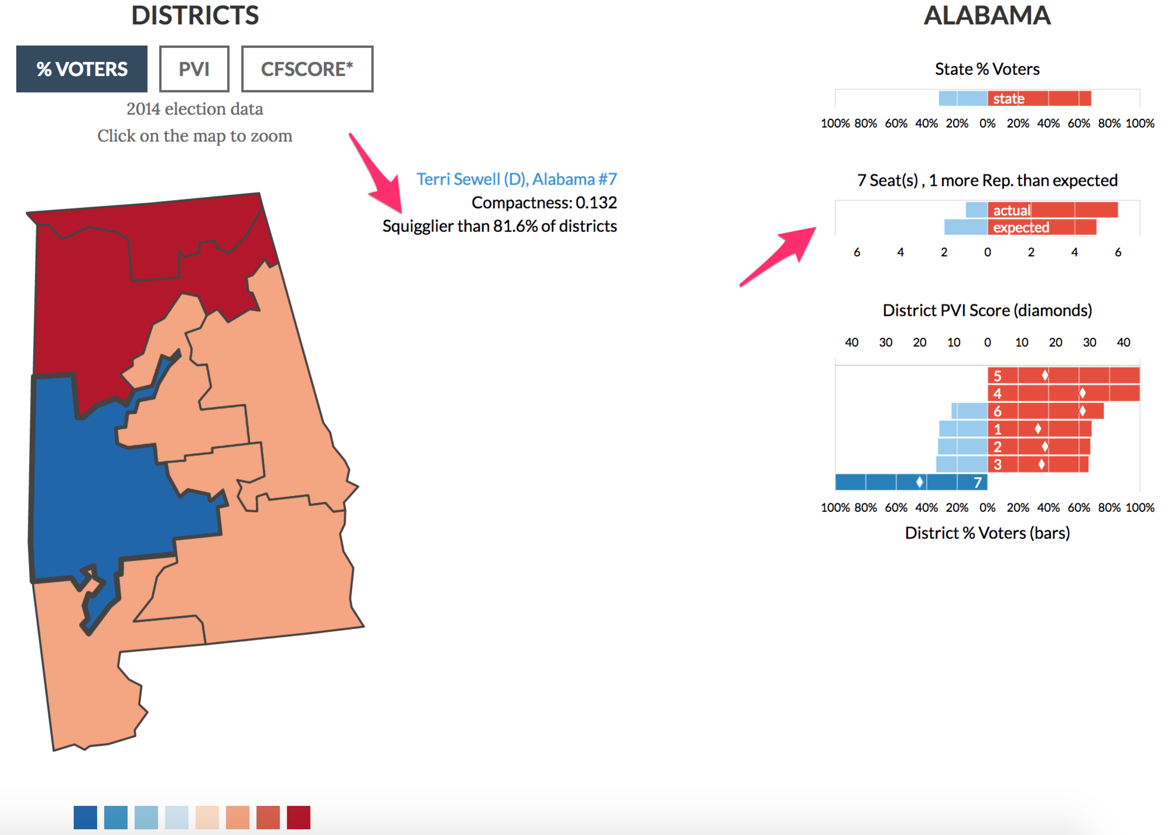

Figure 4

Silicon Valley Data Science Visualization24

Patrick Han’s blog entry The Most Gerrymandered States Ranked by Efficiency Gap and Seat Advantage[28] has many useful links and analyzes efficiency gap. His visualization (Figure 5) shows an excellent method to compare % of votes with actual vs. expected seat wins by party. Data is not available. Note that Patrick Han uses a 25% of votes for the losing party in the calculation of efficiency gap for uncontested wins. We are not convinced this approach is sound. In our calculations we consider zero votes for opposing party in uncontested district wins. The second plot by Patrick Han (Figure 6) shows efficiency gap numbers expressed as total lost seats by state.

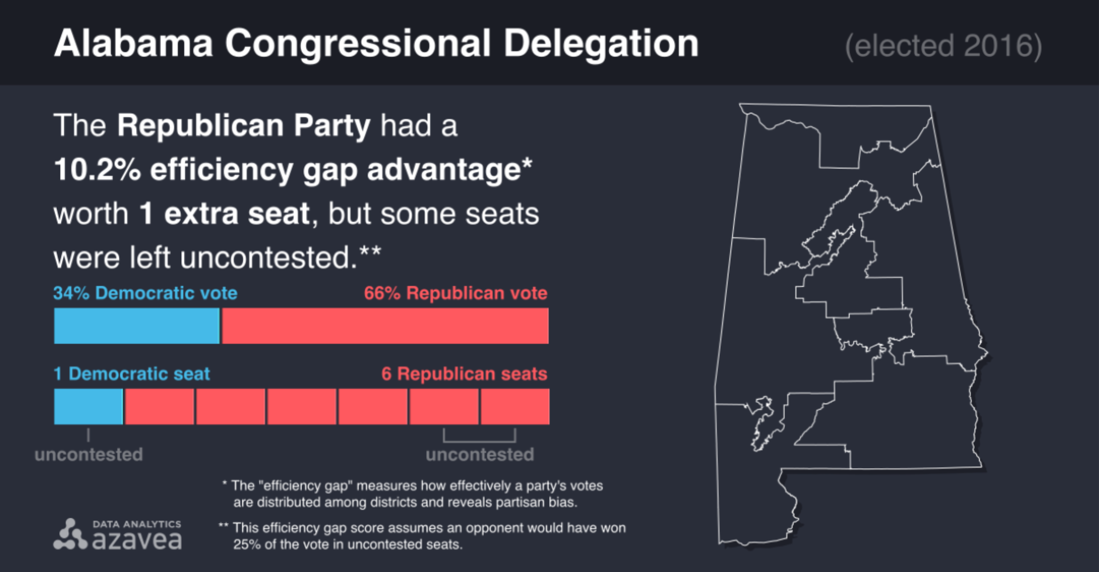

Figure 5

Patrick Han’s Visualization for Alabama26

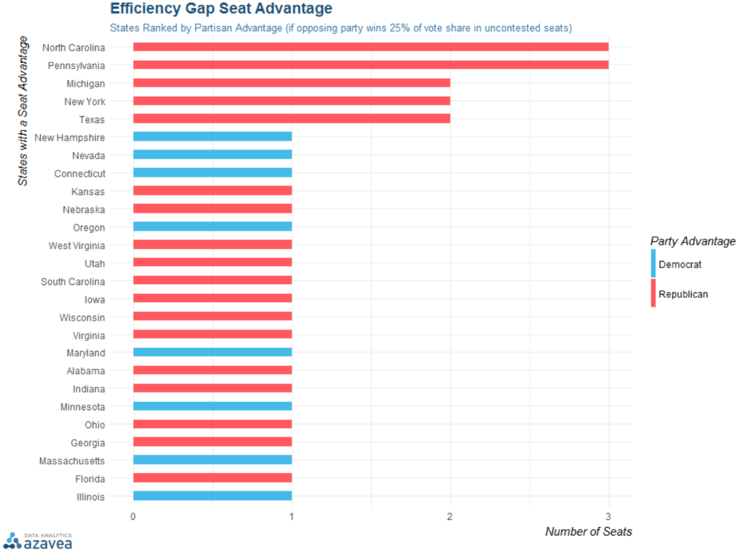

Figure 6

Patrick Han’s Visualization for Efficiency Gap Advantage26

An example of even more compact way to show percentage of votes in contrast with number of seats won is offered by Nate Silver on a New York Times visualization.[29] It does not show however the number of seats one as an integer, which is a nice feature of Patrick Han’s visualization.

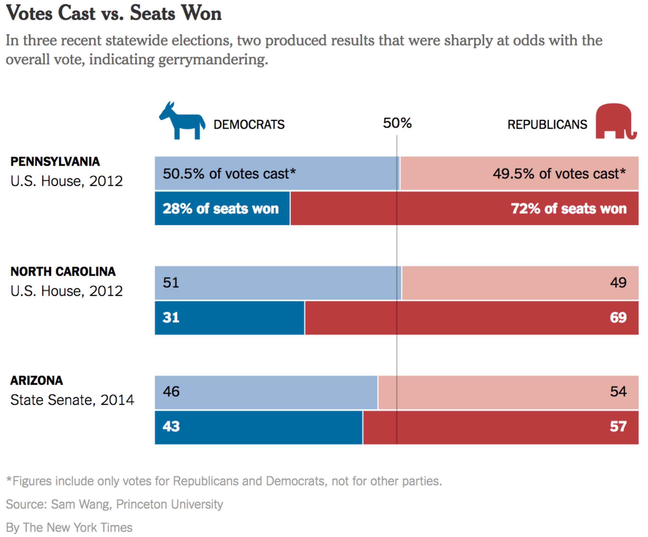

Figure 7

Votes Cast vs. Seats Won Visualization27

The last visualization we wish to mention is from the Princeton University website gerrymander.princeton.edu.[30] It has many useful links, proposes a test to determine if a state has gerrymandering, and allows users to explore how gerrymandered their state is (Figure 8). The color scale on the map goes from “unlikely to be gerrymandered” (green) to “definitely gerrymandered” (red), and suggests number of seats gained due to gerrymandering. The color choice for the scale is not ideal but seeing all states categorized based on gerrymandering is very insightful. The website uses three statistical tests to assess gerrymandering.[31] The tests do not include efficiency gap analysis.

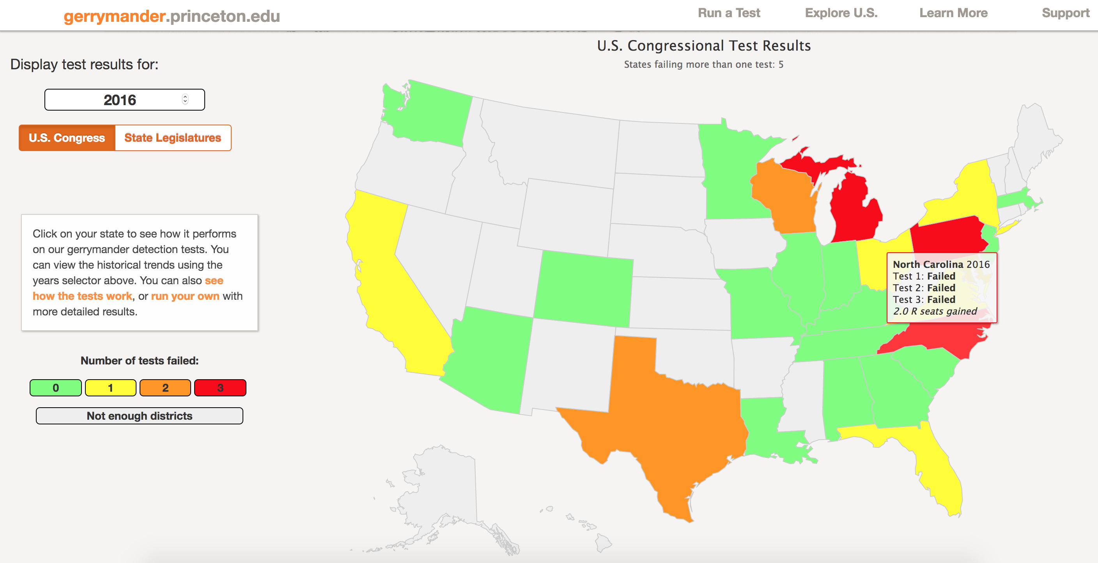

Figure 8

gerrymander.princeton.edu28

# Project Unique Contribution

Unlike the visualizations we identified in our research, our project explores gerrymandering using a top down approach that starts from an analysis of election results at the national level, and drills down to states using number of votes needed to elect house representatives as the starting point of our analysis.

We extrapolate the common notion of “power”, defined in the Merrian-Webster dictionary as “the ability to act or produce an effect” to mean the ability to successfully elect a candidate of one’s choice.[32] We produce visualizations to show that power is not equitably distributed across the electorate, in the sense that electors from certain parties, in different states, are able to elect their representatives with fewer votes than their opponents. At the national level, we confirm the Wikipedia infobox from Figure 2; in the whole, in the 2016 House of Representative elections, Republican electors had more power than Democrat electors.

We believe our approach provides a context in which to analyze gerrymandering that is useful because it highlights how this practice contributes to a larger issue. In fact, if we agree with the Declaration of Independence that “all men are created equal”[33] there is no reason we should accept that certain electors possess more power than others. (Power in the sense we discussed above). So, redistricting that risks creating an imbalance of electoral power is immoral, whether unlawful or not. We hope the flow of our visualizations provide new insights into the issues of electoral power and representation associated with gerrymandering.

# Data

Project data was scraped from the New York Times (NYT) House Election Results: G.O.P Keeps Control webpage,[34] seen in Figure 3 below. Election results data at state district level is stored in a single variable in the html code, in JSON format, so it was relatively straightforward to parse the file to obtain election results data, and create the raw dataset for the project.

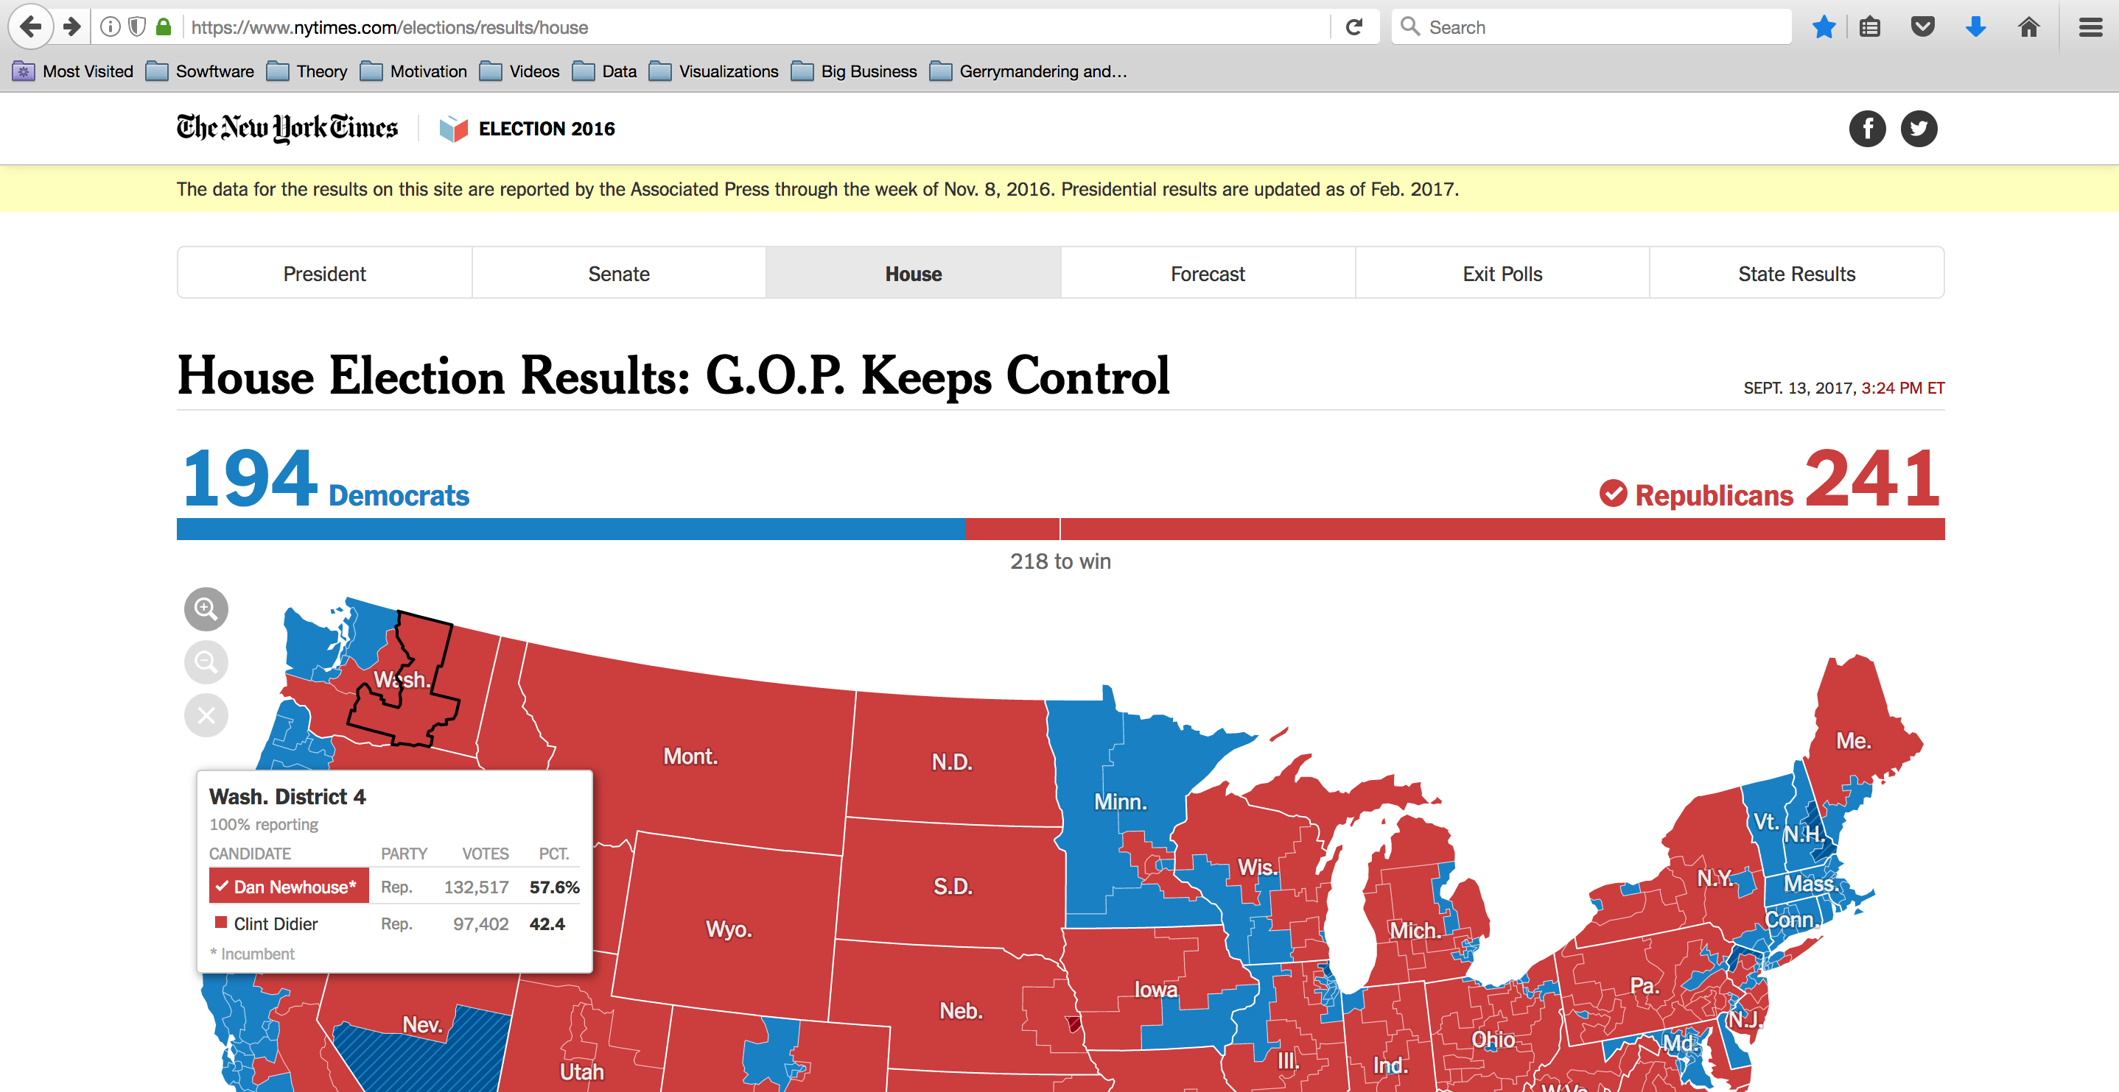

Figure 9

New York Times webpage “House Election Results: G.O.P. Keeps Control”31

Structure of the raw dataset:

| **#** | **Column** | **Descr** | **Data type** | **Comment** |
| --- | --- | --- | --- | --- |
| 1 | candidate_id, ' | Candidate ID | String, Nominal | Unique at country level (dataset) |
| 2 | candidate_key | Candidate Key | String, Nominal | Unique at state level |
| 3 | first_name | Candidate’s first name | String, Nominal |  |
| 4 | incumbent | Incumbent? | Boolean | True or NaN |
| 5 | last_name | Candidate’s last name | String, Nominal |  |
| 6 | name_display | Candidate’s full name | String, Nominal |  |
| 7 | order | Ordering when displaying candidate in the NYT source webpage | Integer, Ordinal | Sort by number of votes descending at the state level |
| 8 | party_id | Party of candidate | String, Categorical | There are 25 distinct party values |
| 9 | percent | Percentage of votes received. | Float, Continuous |  |
| 10 | percent_display | Percentage of votes received. | Float, Continuous |  |
| 11 | seat | District number | Integer, Categorical | Seat is a synonym to district number |
| 12 | state_id | Tow letter state abbreviation | String, Categorical | There are 50 distinct states in the dataset, as expected |
| 13 | votes | Number of votes received | Integer, Discrete |  |
| 14 | winner | Winner? | Boolean | True or NaN |

Pre-processing included many clean up steps and a large number of aggregations and summarizations to allow visualization programs to retrieve data directly with minimal to no need for additional data processing. The NYT data source did not contain vote counts for the many uncontested wins in the 2016 election.

An uncontested win is one in which one of the following scenarios happen:

1. Only the winning candidate receives all votes
2. The winning candidate has not opponents
3. Candidate(s) other than the winning candidate do not appear on the ballot (write-ins)

Votes for uncontested wins were imputed as the average number of votes per district for the given state of the winning candidate. We plan to find, and load real data for uncontested wins in a future release of the project, if time permits.

# Methods: Ideas, Sketches, Prototypes

To illustrate initial visualization ideas for the project, we initially explored examples of efficiency gap on paper, using Figure 1 from the introduction. Below we show one example of such explorations. The calculations are based on Eric Petry’s explanation of the efficiency gap in the article How the Efficiency Gap Works.[35]

Example: Heavy gerrymandering, high irregular district boundaries. From Figure 1, 3nd scenario; assumes districts are numbered top to bottom, left to right.

|  | **Red Votes** | **Blue Votes** | **Wasted Red** | **Wasted Blue** | **Net Wasted** |
| --- | --- | --- | --- | --- | --- |
| District 1 | 6 | 4 | 0 | 4 | 4 Blue |
| District 2 | 6 | 4 | 0 | 4 | 4 Blue |
| District 3 | 6 | 4 | 0 | 4 | 4 Blue |
| District 4 | 1 | 9 | 1 | 3 | 2 Blue |
| District 5 | 1 | 9 | 1 | 3 | 2 Blue |
| Totals | 20 | 30 | 2 | 18 | 16 Blue |

Net 16 blue votes wasted / 50 total votes = 32% efficiency gap favoring red voters

After creating the dataset for the project, we were naturally drawn to pursue a top down approach starting with issues of representation at the national level, as illustrated in Figure 2. Later, due to some unsuccessful visualizations we further realized that gerrymandering and the efficiency gap only make sense under certain circumstances; only when the proportion of votes for a party exceeds the proportion of seats won by a full whole numbers does it make sense to consider the efficiency gap. In other words, unless a party has enough votes in the state to elect at least one more candidate, redistricting to benefit the loosing part wouldn’t grant the party an extra seat anyway.

Analysis of wasted votes was another idea we pursued and abandoned. Figure 4 shows is a visualization we will not use in the final project because wasted votes need to be considered in context and we did not find a good context yet in which to present this metric.

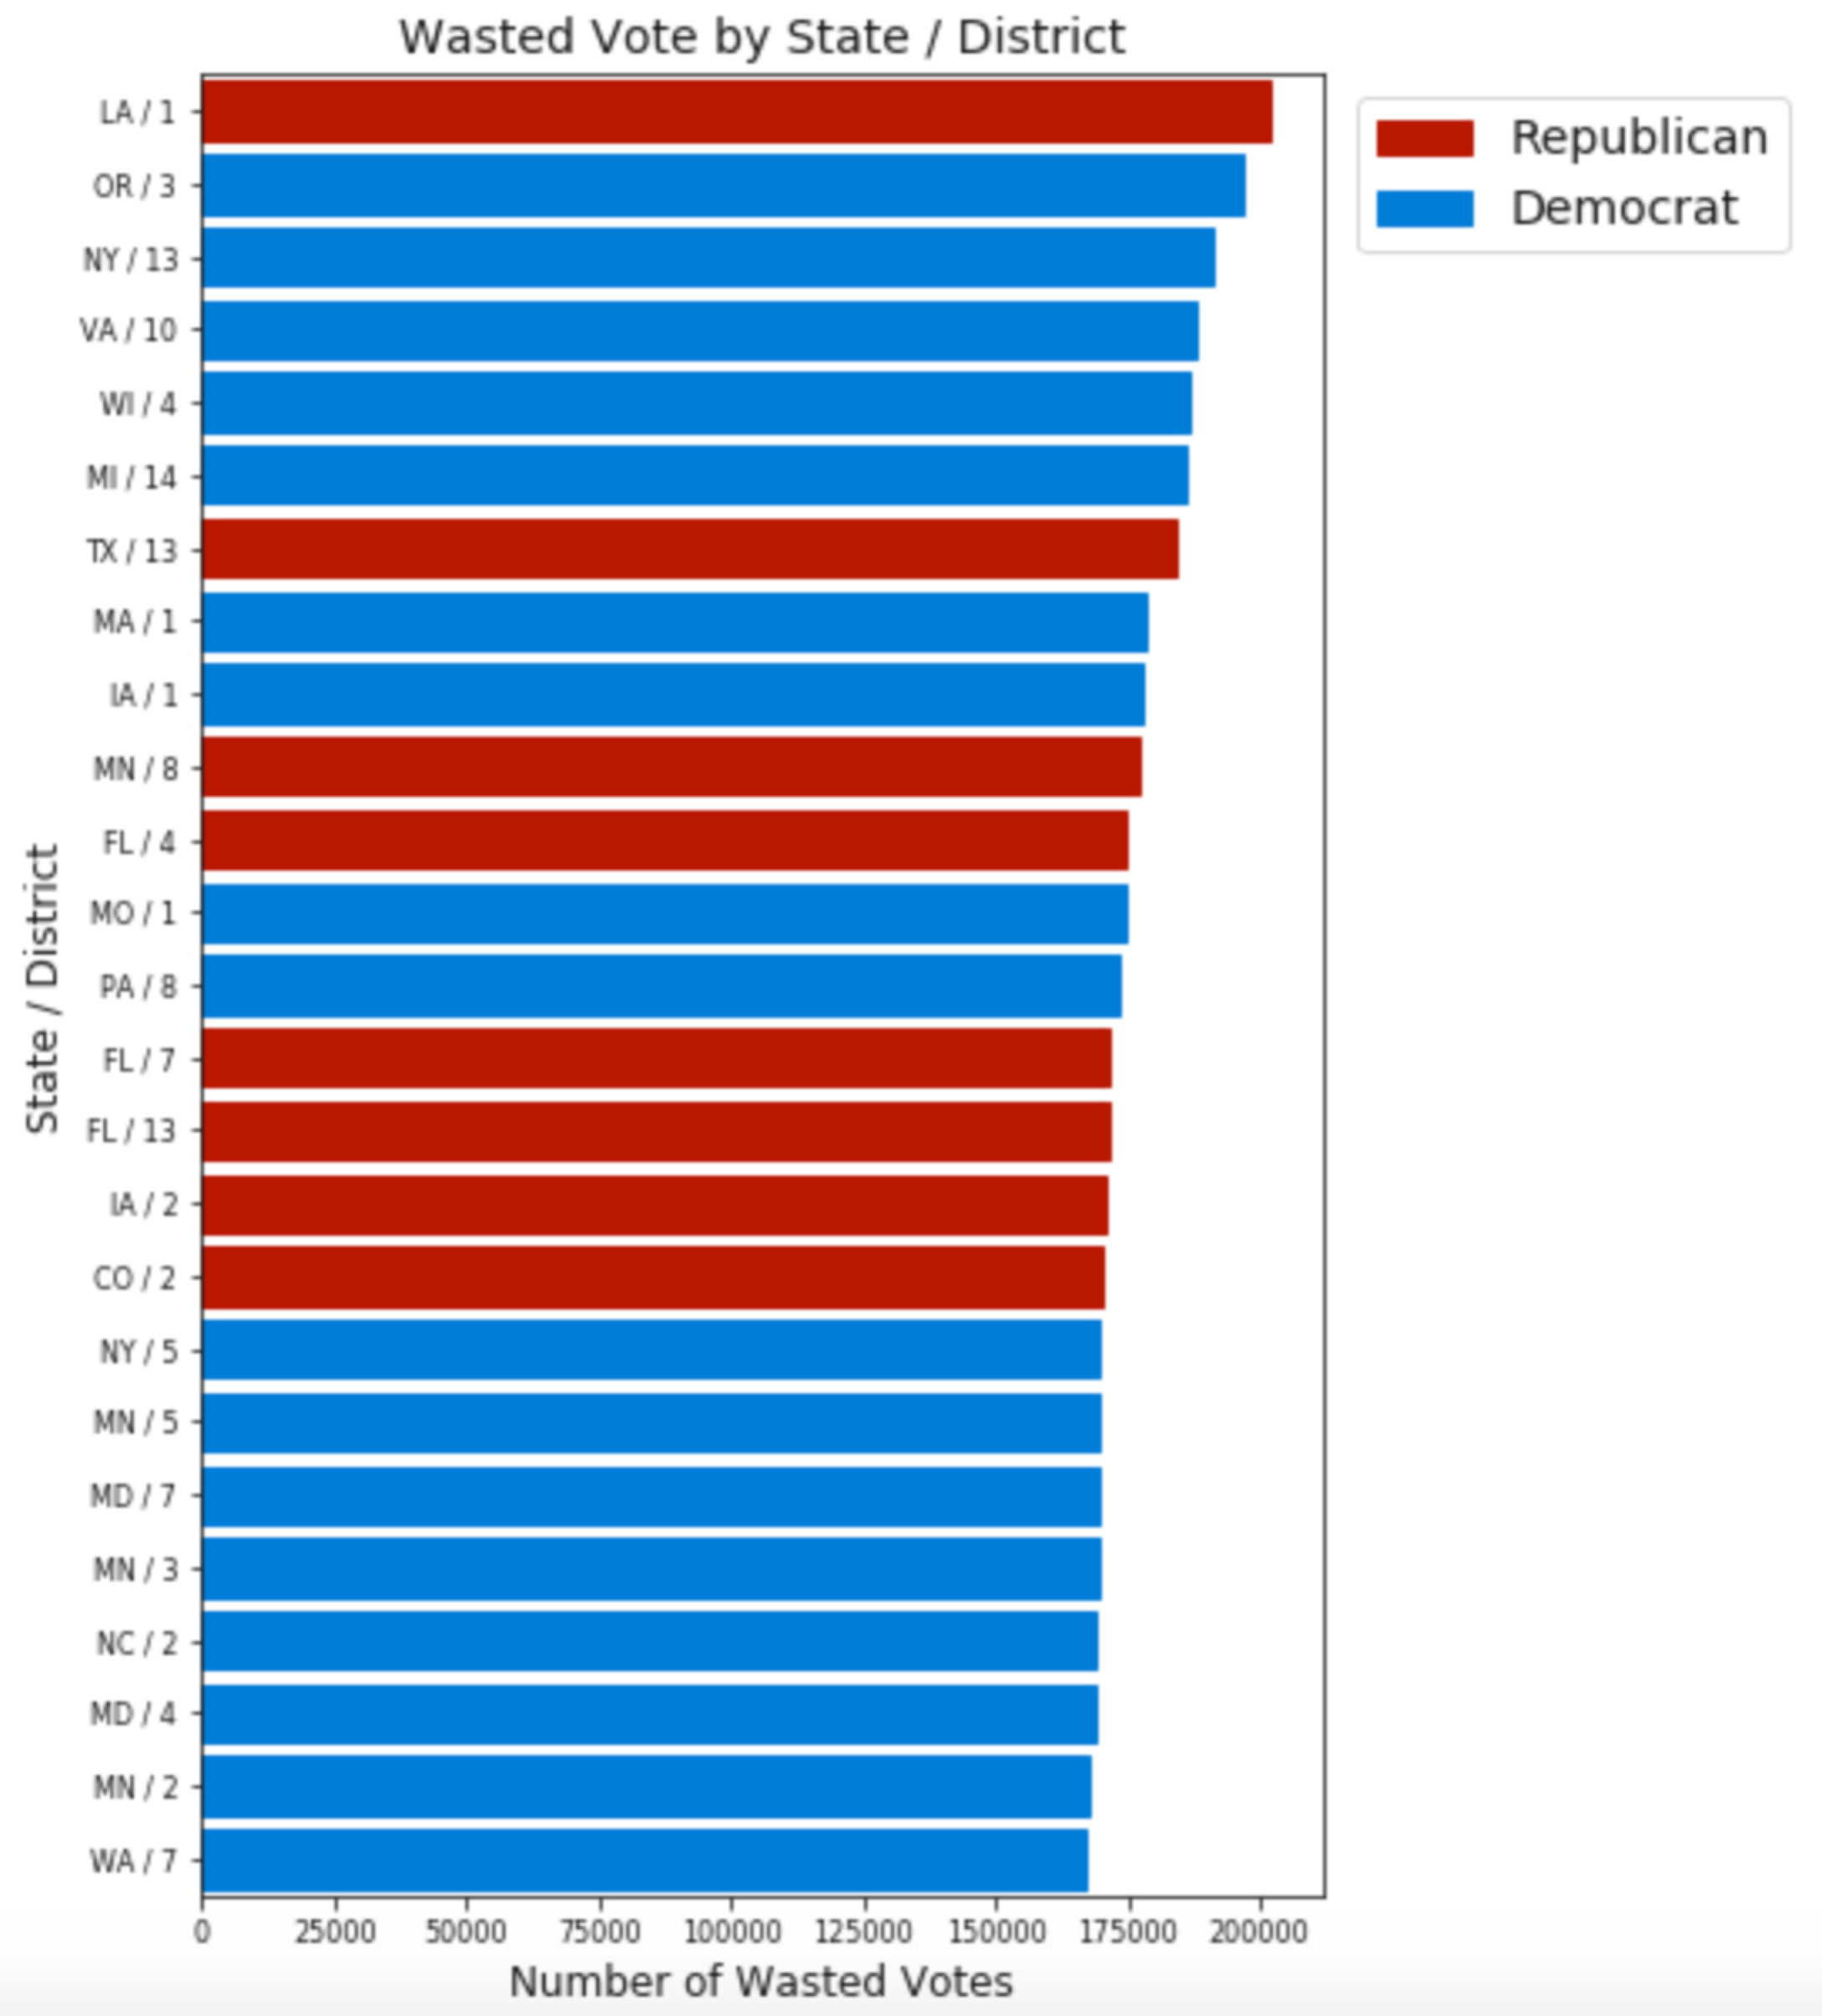

Figure 10

Abandoned visualization showing wasted votes per state / district

These are initial plot ideas we considered. Some of them were selected.

1. Efficiency gap by state (bar chart or heat map with tabular data)
2. Districts with highest relative number of wasted votes (same as above)
3. Seats lost due to districting, by state (percentage of votes vs. percentage of seats)
4. Seats gained due to districting, by state (same as above)

These were ideas for iterative capabilities put forth at the beginning of the project:

1. Allow user to generate plot(s) by first selecting a state
2. Allow user to generate plot(s) by first select top/bottom states on a particular metric
3. Allow user to generate plot(s) that display total for entire country
4. Add links to the plots so user can jump to Congressperson’s webpage
5. Add links to organizations that are fighting gerrymandering
6. Add links to pages that educate on the subject

We are still considering implementing an interactive visualization, if time permits. In the results section of this document we will describe how we envision the interactive visualization could work.

The following research questions and working hypotheses were put forth at the onset of our project:

1. Are wasted votes a good indicator of gerrymandering?
2. Is the efficiency a gap good indicator of gerrymandering?

We expected that yes; both wasted votes and efficiency gaps would be good indicators of gerrymandering. At this point we believe neither is *per se* a good indicator of gerrymandering and we decided to not focus on wasted votes, since wasted votes are included in the formula to calculate gerrymandering. By contextualizing the efficiency gap properly we believe it is a good indicator of gerrymandering.

At the proposal phase of the project we planned to confirm our findings by analyzing the shape of the districts in the states where the efficiency gap suggests gerrymandering is occurring. This verification will be performed manually at this first phase of the project, i.e., by searching online for the state and district maps. In the results section of this document we describe our findings analyzing maps based on efficiency gap numbers.

# Methods: Visualization methods selection

We mostly analyze categorical data that primarily falls into 3 categories (the “parties”[36]) and secondarily can be grouped by State (52 categories) or State and District (there were 435 districts at play in the 2016 election). We selected bar charts as the natural choice to compare numbers of votes across these categories.

We selected a top-down approach to visualize gerrymandering, starting with US number of votes vs. seats won, and drilling down to states. We developed a series of questions to guide the visualization and tell a story that shows where gerrymandering is at play, where it is not, when the efficiency gap metric works well as measure of gerrymandering, and when it doesn’t. We summarize our findings in the conclusion of our report.

Based on our experience analyzing the election results data using Jupyter Notebook and interacting with the various visualization programs we developed, we can envision an interactive webpage that would allow users to explore issues of representation in general and gerrymandering in particular. In the conclusion section of the document we offer some details of a future interactive visualization.

# Results

Questions 1 – Where did the votes go?

Republican electors casted about 1% more votes than democrats in the 2016 House of Representatives election. Yet, they were able to elect about 24% more candidates than democrats.

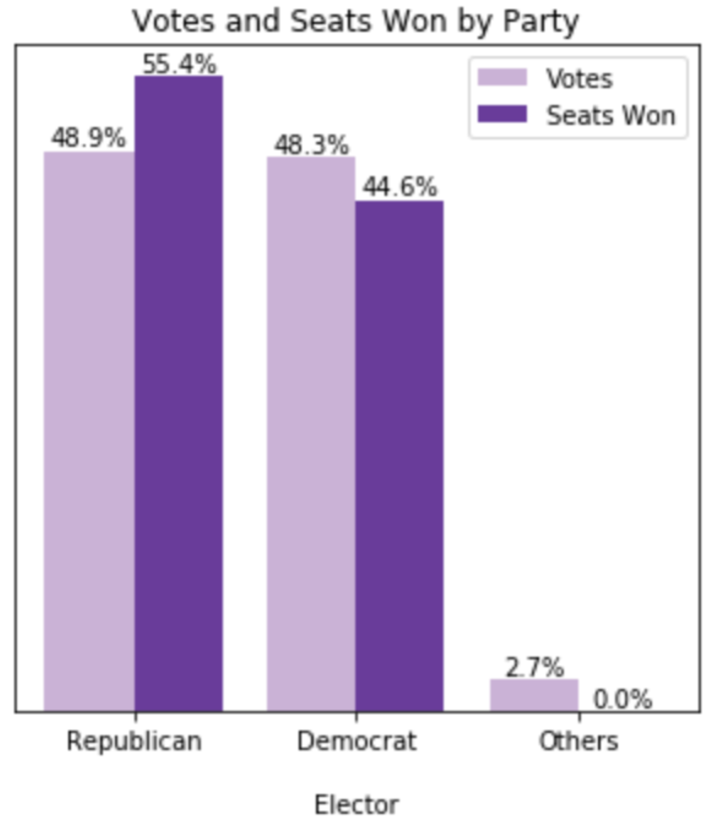

Question 2: Do republican electors have more power?

Power is defined by the Merriam-Webster as the "ability to act or produce an effect".29 On average, it took roughly 20% more Democrat electors to win a seat for their party, than it took Republican electors to elect a Republican candidate. In that sense, Republican electors had more power in the 2016 House of Representative elections. The next plot “More is less” shows that *more votes* to elect a candidate means *less power*.

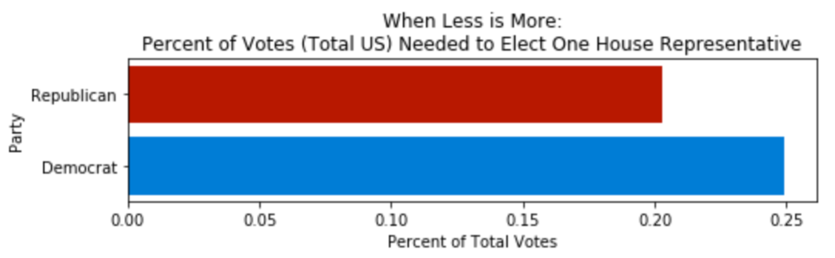

Question 3: How do state and national numbers compare?

Numbers at the state level reveal even more strikingly that Democrat electors needed more votes on average to elect their representatives to the House of Representatives than did Republican electors. The horizontal lines on the graphs below show the national average votes needed to elect a candidate of each party.

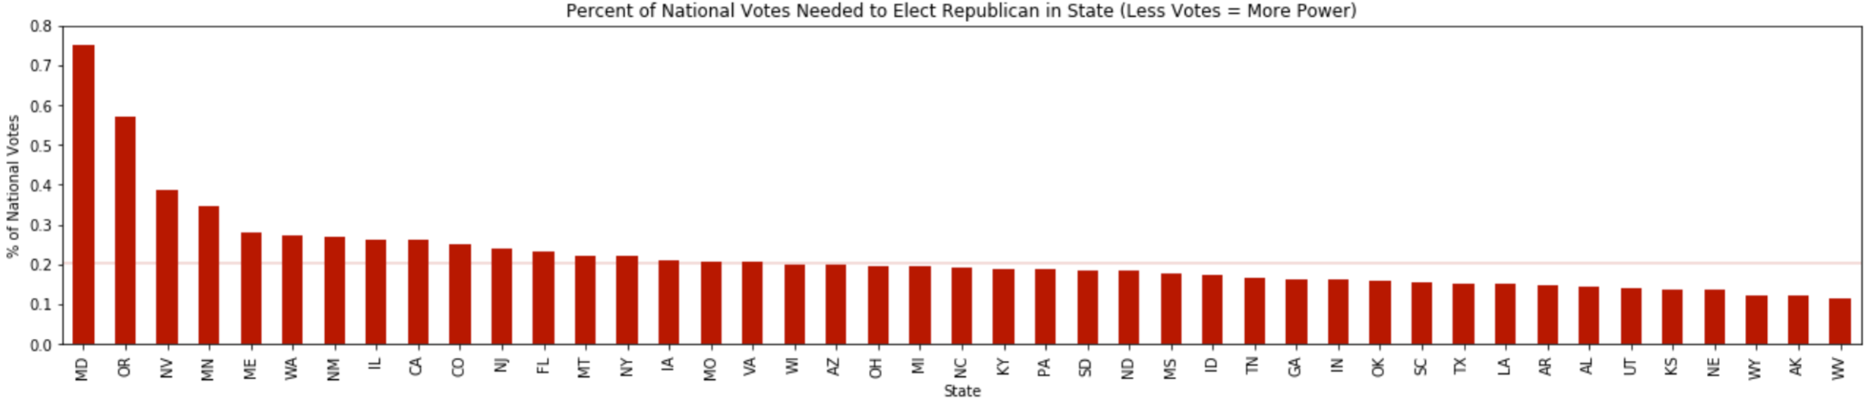

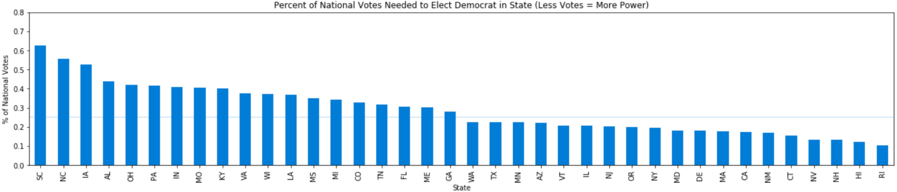

Question 4: How do party numbers compare at the state level?

The problem we saw with Democratic electors needing to cast more votes to elect their candidates is exacerbated when we look at numbers at the state level. Clearly democrats were disadvantaged in more states, and often in a more significant way.

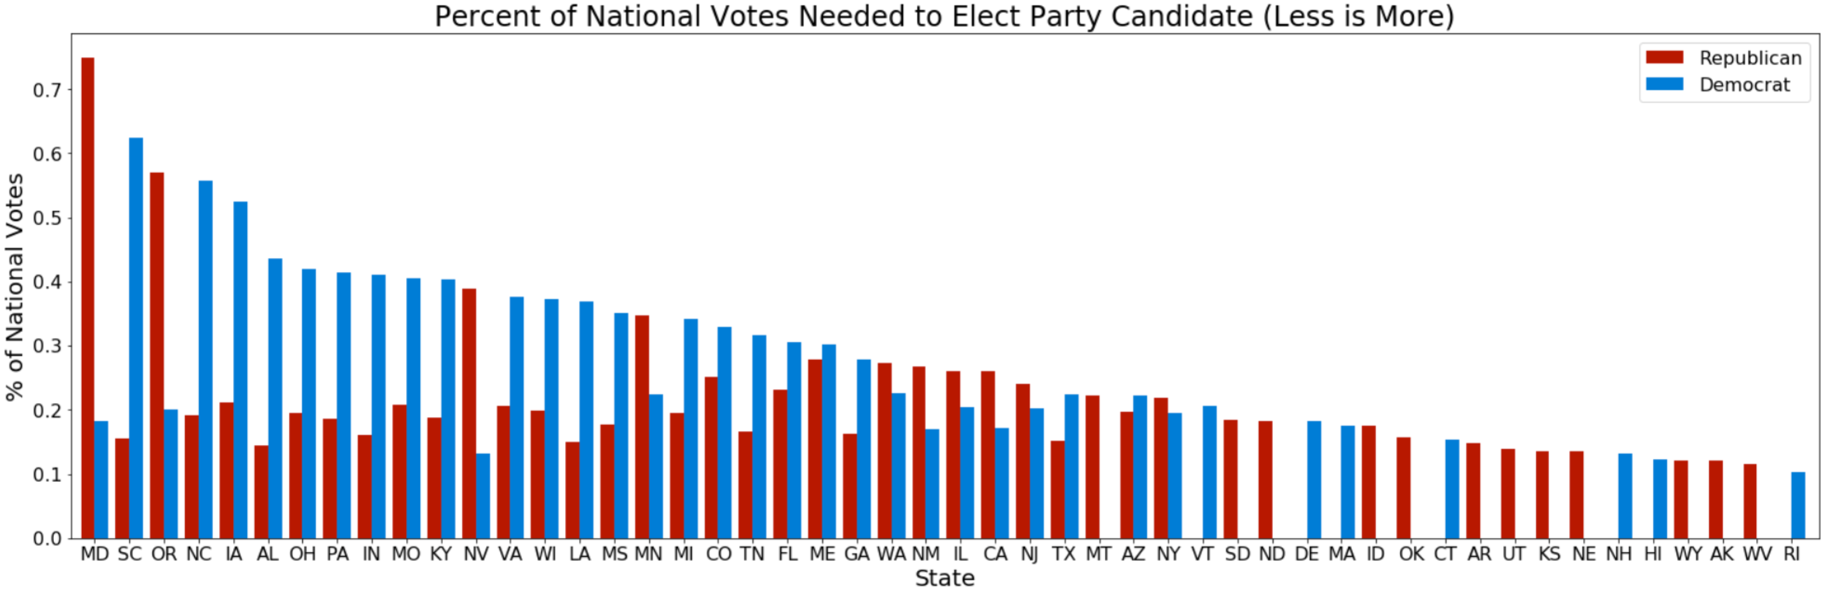

Question 5: How are votes cast on states where a party has extreme advantage?

By looking at the previous plot, we can identify many states where one of the two parties appears to have substantially more power. We now analyze 3 of them: Alabama, Connecticut and Oklahoma.

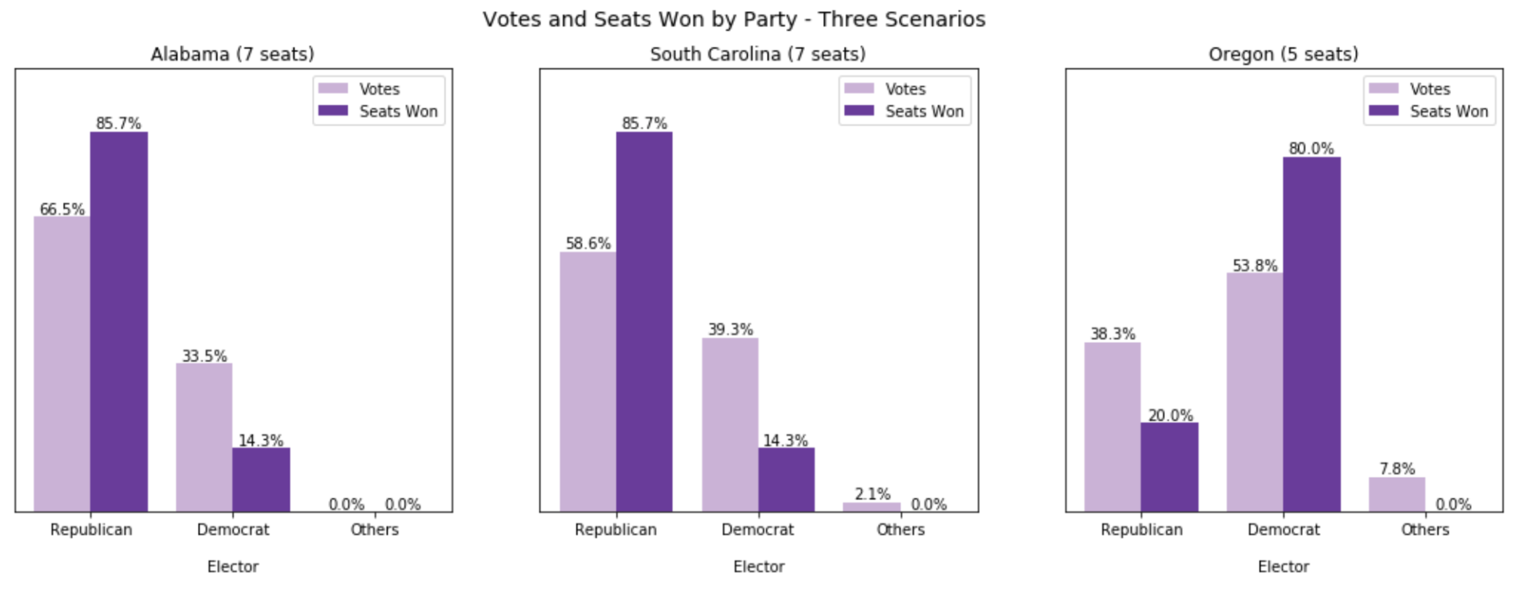

Alabama

Below we show the election results for Alabama at the district level.

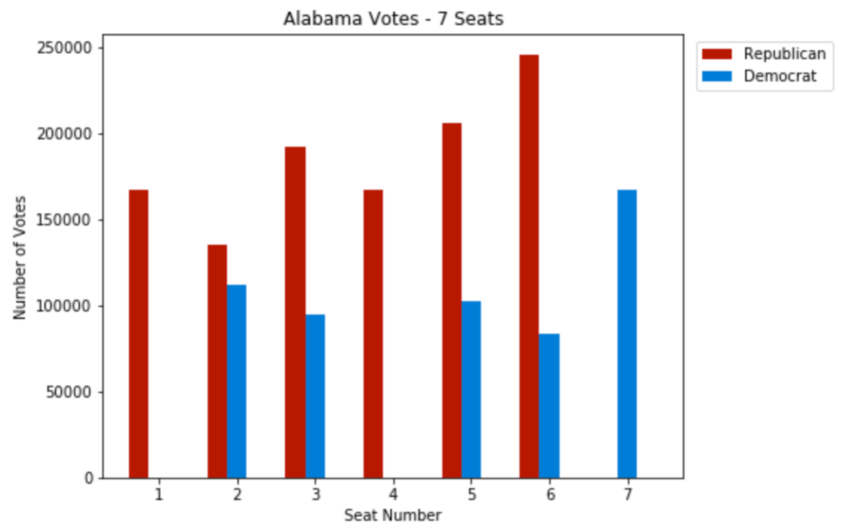

There are two strategies to gerrymander a state. The first one is to draw district lines to dilute the votes of one party across many districts, so the unfavoured party will win no seats or fewer seats – that is called “cracking”[37]. The second strategy is to concentrate votes of a party in a few districts, where that party will then win in a landslide, leaving other districts up for easy wins to the opposing party – that is called “packing”.

Both “cracking” and “packing” appear to be at play in Alabama. If districts 2 and 3 are adjacent, it is conceivable that district lines were intentionally drawn to split (“crack”) blue votes. If district 7 is close to district 5, it is conceivable that district lines were intentionally drawn to isolate blue votes in district 7, ensuring a red win in district 5 (“packing”).

The district map for Alabama is shown next (source wikipedia[38]). Note the wiggly shape of the district lines.

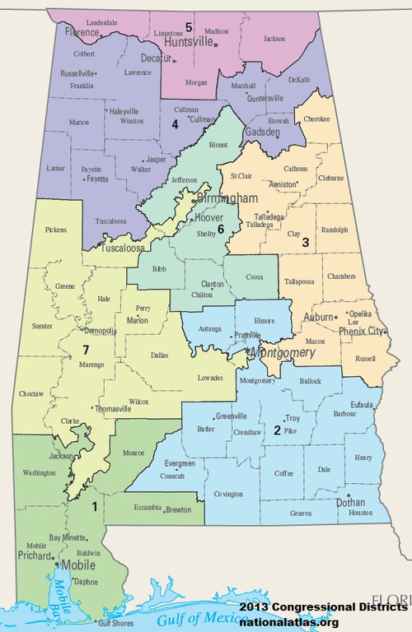

South Carolina

Below we show the election results for South Carolina at the district level.

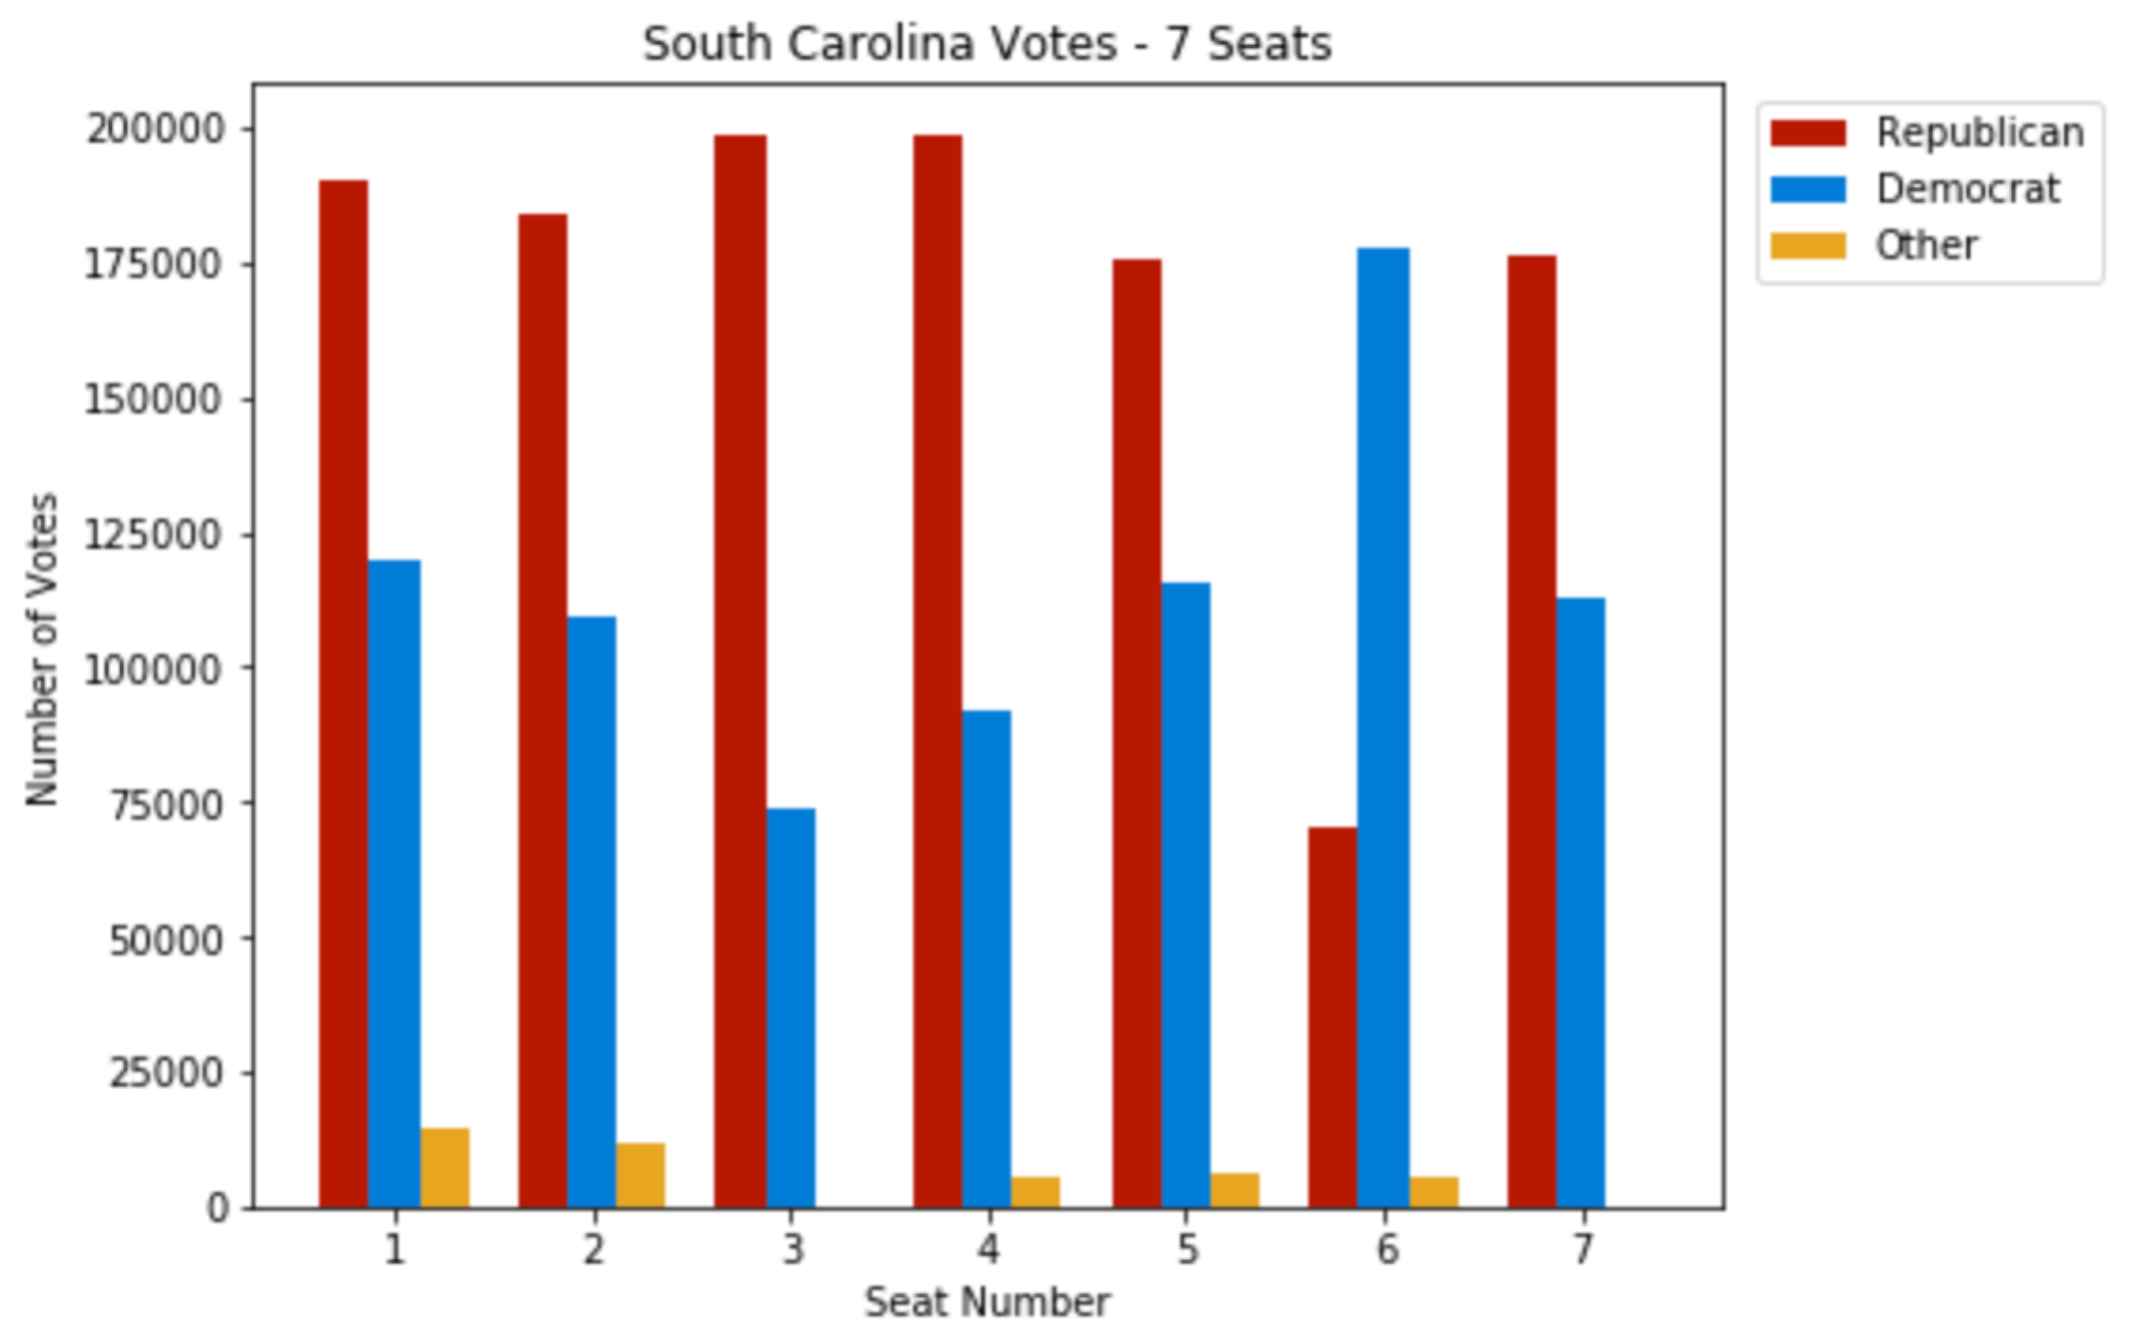

Gerrymandering appears to be happening in South Carolina, specifically “cracking”, since many blue votes we see on the plot are spread across several districts that are likely adjacent. The district map for the state below35 confirms what the plot suggests for districts 5 and 7. Packing of blue votes in district 6 favors red win in district 1. Note the wiggly shape of district lines delineating districts 1, 2 and 6.

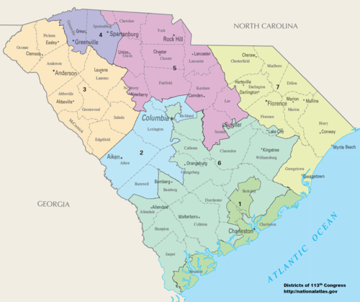

Oregon

Below we show the election results for Oregon at the district level.

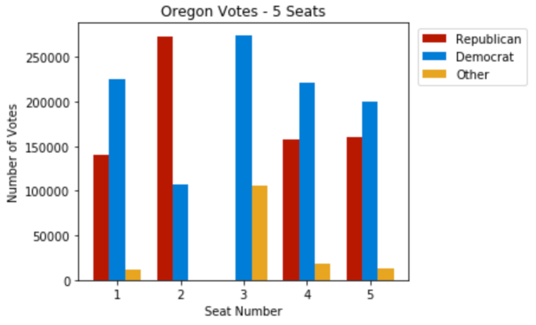

Unlike Alabama and South Carolina, Oregon shows a strong presence of a third party. The presence of a third party exacerbates the imbalance of power between red and blue voters that we see in the plot from question 3. Still, red votes are diluted across districts 1, 4 and 5, which are adjacent per the Oregon district map below.35

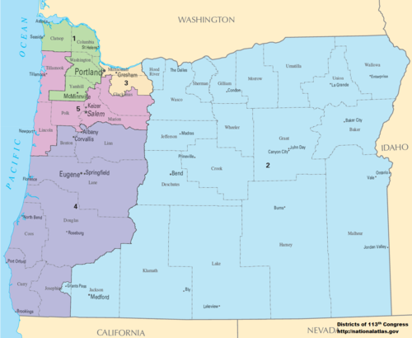

Would it be fair to move district boundaries for districts 1, 4 and 5 to make red votes more competitive? We don’t think so. An operating assumption that drives the motivation to eliminate gerrymandering is the realization that election results are unfair. But if we look at Oregon election numbers, the proportion of seats won by Republicans and Democrats was 1:4. Even though red votes are diluted across districts 1, 4 and 5, and even though red votes appear to be concentrated in district 2, together their proportion to blue votes is less than 2:3. Therefore the election results in Oregon can be deemed fair.

Question 6: Can the efficiency gap help identify gerrymandering?

The efficiency gag is calculated as the “the difference between the two parties' wasted votes, divided by the total number of votes”.[39] The calculation of wasted votes is not straightforward if there are more than 2 parties participating in the election. This is how we calculated wasted votes on this project:

* For districts with one uncontested candidate
  + All votes from winner beyond simple majority are considered wasted votes.
* For districts with two candidates:
  + All votes from losing candidate are considered wasted votes.
  + All votes from winner beyond simple majority are considered wasted votes.
* For districts with more than two candidates:
  + All votes from losing candidates are considered wasted votes.
  + All votes from winner beyond second most voted candidate plus 1, are considered wasted votes.

Note that many states are naturally not included in the gerrymandering analysis. All states with a single district are excluded, since gerrymandering doesn't apply when a state only has one seat to fill. Additionally, all states that have a proportion of red vs. blue votes that is not large enough to justify an additional seat are excluded as well. That was the Oregon case we discussed in the previous question.

Below is the plot showing the efficiency gap, by state, for the 2016 US House of Representatives election. As expected, Alabama appears on the list with value close to 7.5%. So does South Carolina, with a much higher efficiency gap of 12.5%. We will analyze a few different states to confirm the efficiency gap is an effective tool to assess gerrymandering.

Efficiency Gap by State

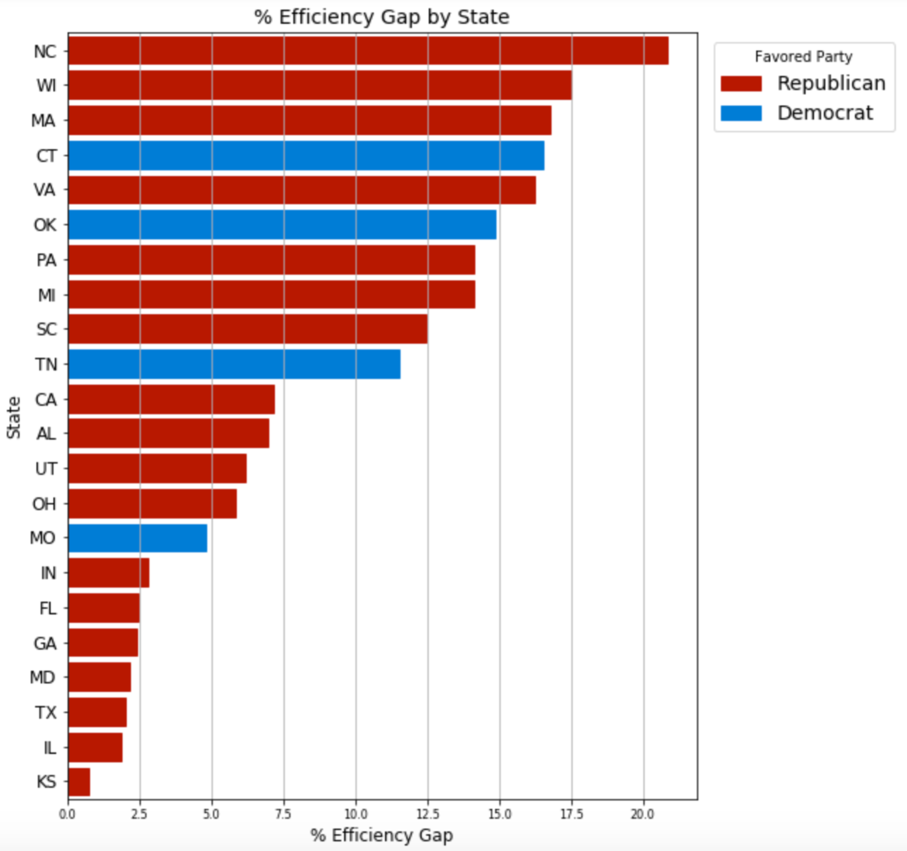

We will analyze North Carolina, Connecticut and Oklahoma.

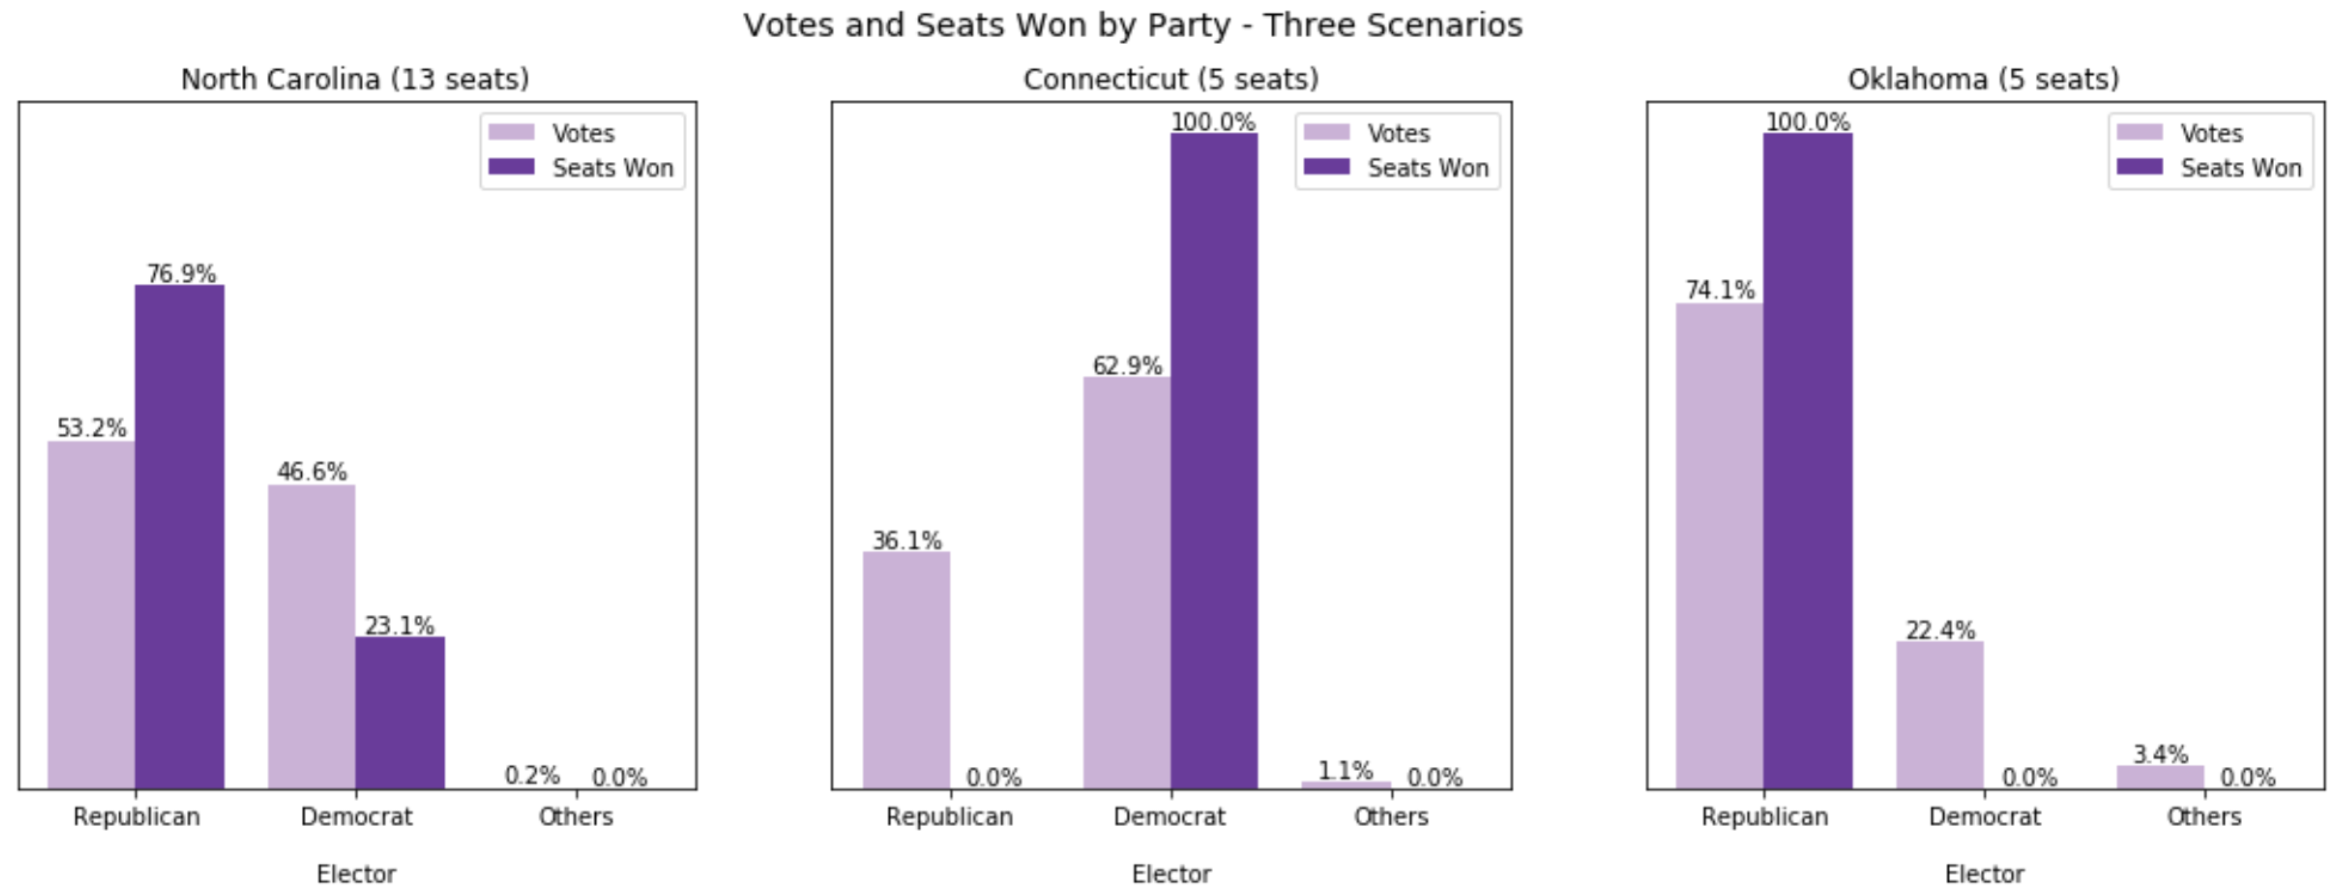

North Carolina:

Below we show the election results for North Carolina at the district level.

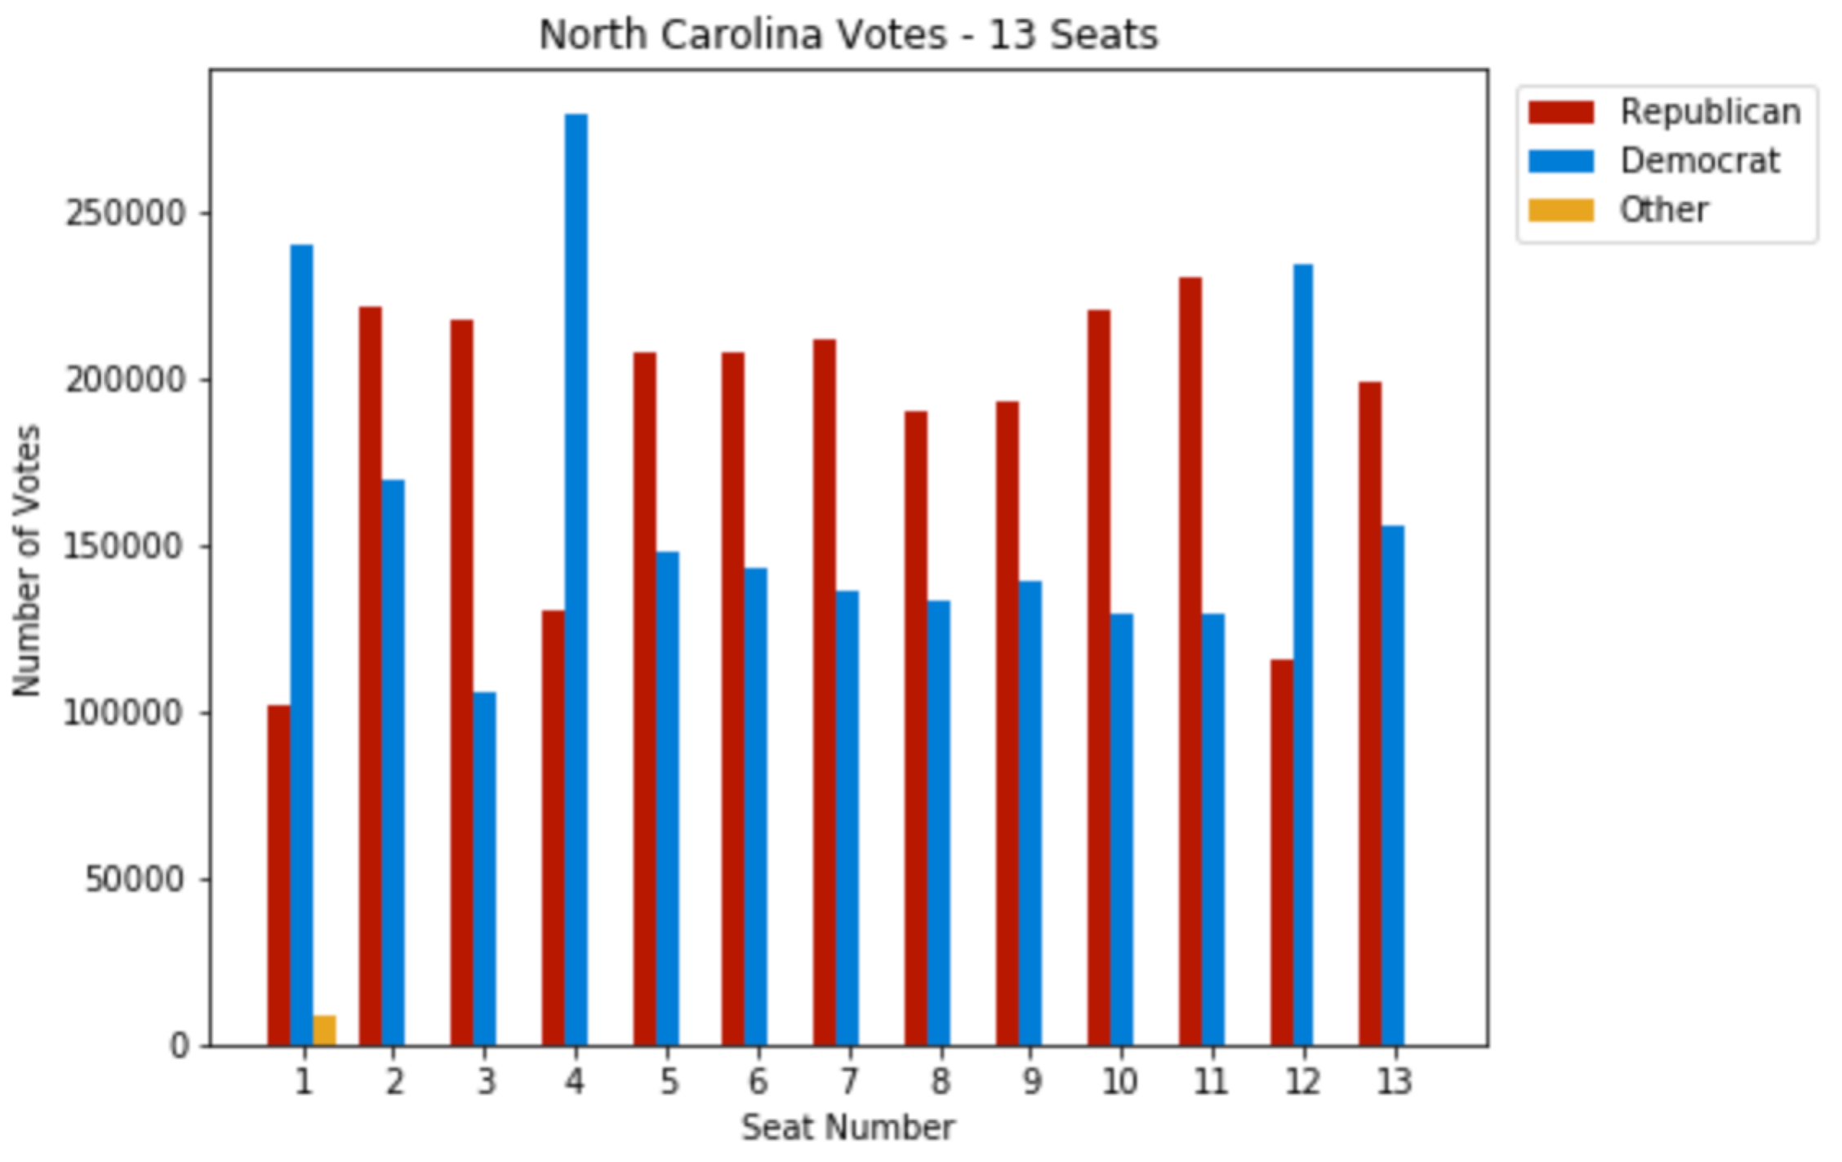

We see three relatively easy blue wins for districts 1, 4 and 12, and several relatively close blue losses across several districts, indicating possible gerrymandering through both cracking and packing. The district map in the next page allow for further analysis.

North Carolina district map:

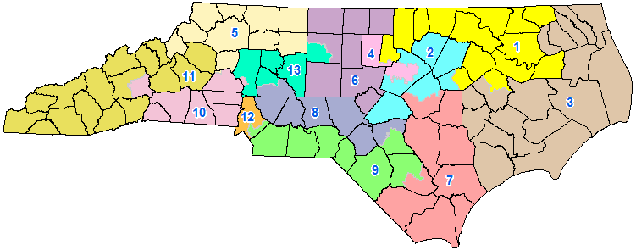

Connecticut:

Below we show the election results for Connecticut at the district level.

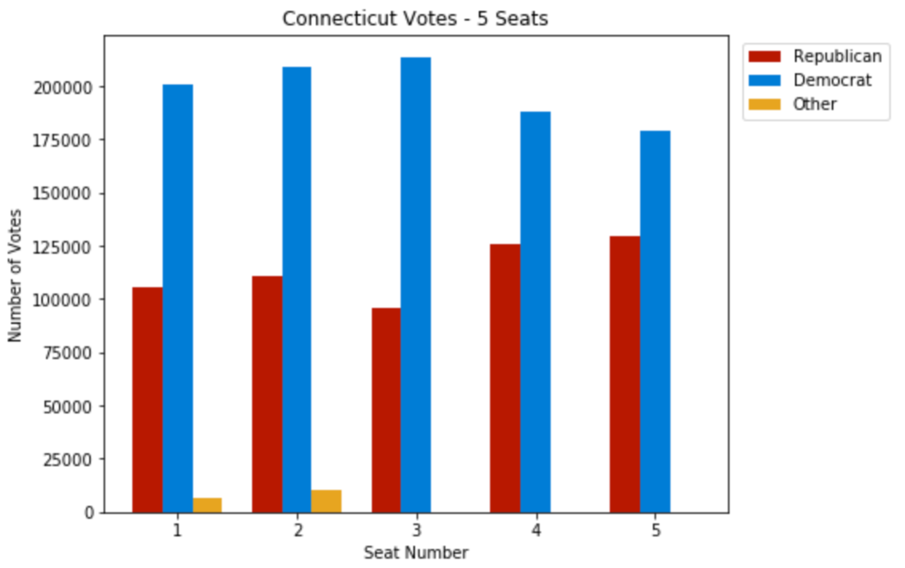

Clearly, red vote dispersion indicates the possibility of gerrymandering. The district map for the state is show next. District 5 encroaching boundaries appear suspicious.

Connecticut district map:

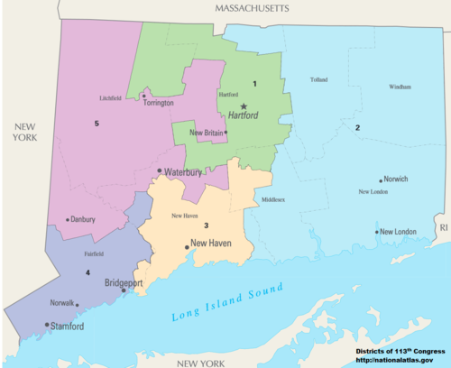

Oklahoma:

Below we show the election results for Oklahoma at the district level.

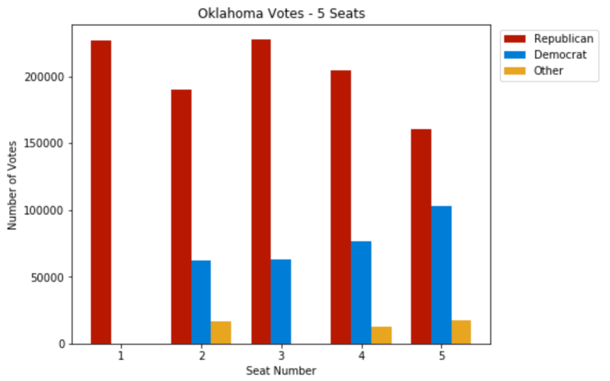

This state demonstrates the limitations of the efficiency gap metric. Note that the efficiency gap shows the Democratic Party as favored but Democrats did not win a single seat, so it couldn’t have benefited from gerrymandering. It does appear that blue votes were diverted from district 5 to facilitate a red win in that district. However, the number of red wasted votes was higher than the number of blue votes overall, so the efficiency gap calculation show democrats as benefiting from gerrymandering.

Oklahoma district map:

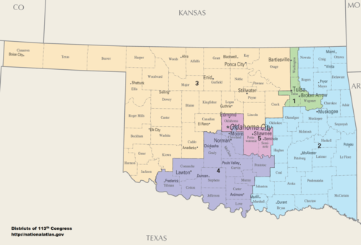

# Conclusions

Our research so far indicates that Gerrymandering is one of the factors causing representation imbalances in the US House of Representatives. We included herein the analysis of Alabama and North Carolina showing “packing” and “cracking” favoring republican candidates. But we also showed the example of Connecticut favoring democrats.

The efficiency gap appears to be flawed, at least in the way it was calculated in our project, for Oklahoma appears in our visualization as favoring democrats, but republicans won all seats for that state. Unless we clarify what is happening with our calculation of this metric, we cannot count on it to assess gerrymandering. We saw a visualization from Patrick Han28 that considers uncontested districts as receiving 25% votes for the losing party. Oklahoma has one uncontested district and that could explain the issue. Further research is needed to review our calculation of the index and to analyze Patrick Han’s rationale for adding fictitious votes in his calculations of the efficiency gap.

What is happening in Maryland? We need to explore further why Maryland shows such a huge imbalance of power in Question 3 and yet doesn’t appear in the efficiency gap plot. Is that due to another limitation of the efficiency gap, and if so what? When comparing balance of power between republican and democrat electors, it is important to consider whether a third party is involved (Oregon case). How does a third party impact the effectiveness of the efficiency gap to assess gerrymandering?

We hope our top-down approach to explore gerrymandering starting from aggregate numbers at the nation level, and the emphasis we put on the issue of power imbalance will provide useful insight into the spurious nature of this political practice. However, unless one can unequivocally identify gerrymandering it will be impossible to assess how much of the power imbalance is attributable to gerrymandering vs. our political winner-takes-all political system. For example, in New Hampshire, which elects two representatives, republicans received almost the same percentage of votes received by democrats but did not win any seats. Can we unequivocally say the state district boundaries were *intentionally* carved to benefit democrats?

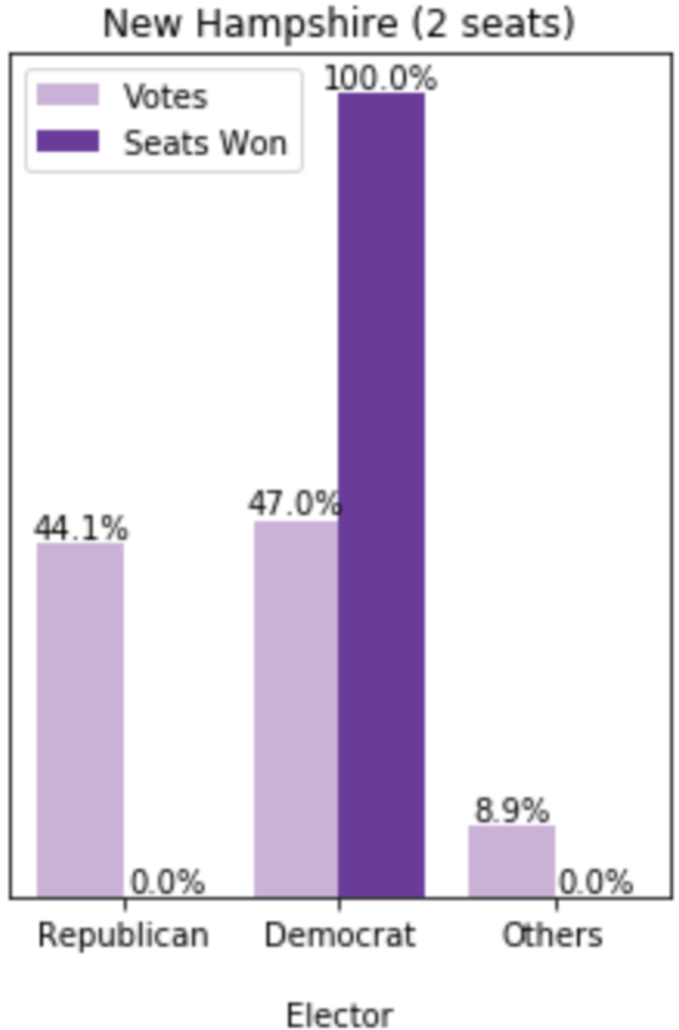 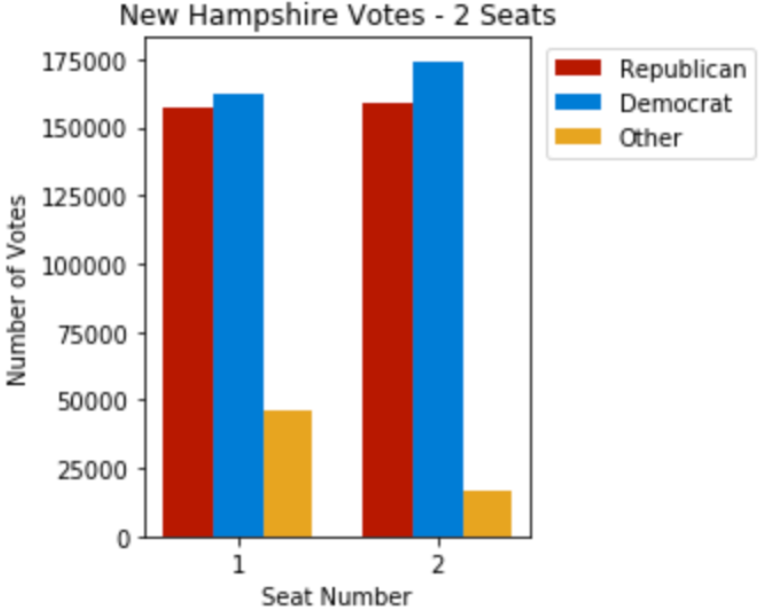 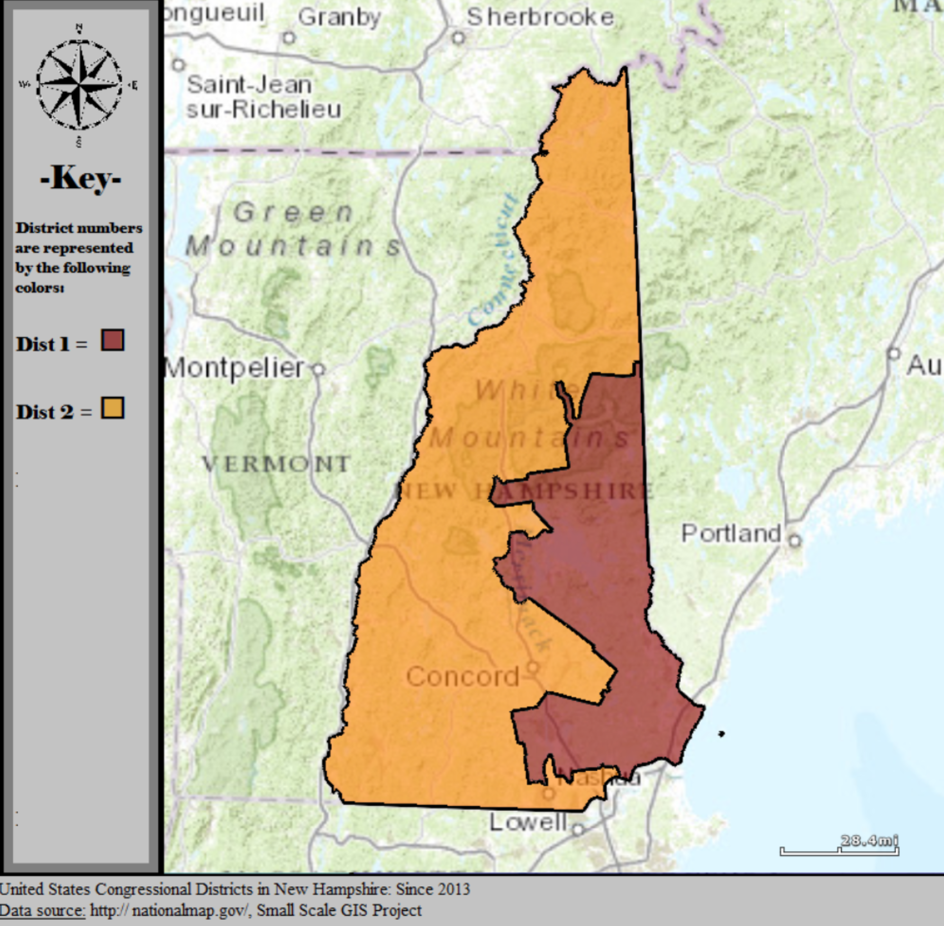

We envision 5 ways to improve our visualizations. On our next release we intend to implement at least the first 2 improvements listed below.

1. Combine visualization of percent votes won with number of seats won by state, using Patrick Han’s visualization, copied below, as a starting point.28

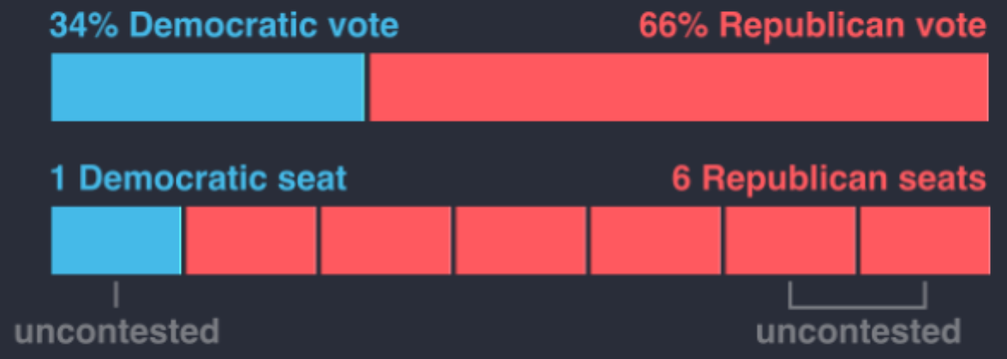

1. Combine plots to provide insight into cause of power imbalance at the state level. Is the cause of the imbalance (1) gerrymandering or (2) winner-takes-all electoral system?
2. Create best guess approach to determine whether power imbalance at the state level is caused by (1) gerrymandering or (2) winner-takes-all electoral system, based on evidence of “packing” and “cracking” of votes at the district level.
3. Create plot to aggregate at the national level, the state level best guess into whether power imbalance was caused by gerrymandering vs. winner-takes-all.
4. Develop interactive visualization.

# Works Cited

Altman, Micah, et al. “Revealing Preferences: Why Gerrymanders Are Hard to Prove, and What to Do about It.” *By Micah Altman, Brian Amos, Michael P. McDonald, Daniel A. Smith :: SSRN*, 23 Mar. 2015, papers.ssrn.com/sol3/papers.cfm?abstract_id=2583528.

Bangia, Sachet, et al. *Quantifying Gerrymandering @ Duke*, Duke University, services.math.duke.edu/projects/gerrymandering/.

Cavell, Nic. “Gerrymandering Is Even More Infuriating When You Can Actually See It.” *Wired*, Conde Nast, 3 June 2017, www.wired.com/2016/01/gerrymandering-is-even-more-infuriating-when-you-can-actually-see-it.

“Cook Partisan Voting Index.” *Wikipedia*, Wikimedia Foundation, 15 Oct. 2017, en.wikipedia.org/wiki/Cook_Partisan_Voting_Index.

Current Partisan Gerrymandering Cases | Brennan Center for Justice, Brennan Center for Justice, 26 Apr. 2017, www.brennancenter.org/analysis/ongoing-partisan-gerrymandering-cases.

DeLancey, Billy. Lobbyists 4 Good, 4 Feb. 2017, www.lobbyists4good.org/single-post/2017/01/23/Is-this-the-root-cause-of-our-political-dysfunction.

Dews, Fred. “A Primer on Gerrymandering and Political Polarization.” *Brookings*, Brookings, 6 July 2017, www.brookings.edu/blog/brookings-now/2017/07/06/a-primer-on-gerrymandering-and-political-polarization/.

FairVote.org. “About Us.” FairVote, www.fairvote.org/about.

“Gerrymandering.” *FairVote*, FairVote.org, www.fairvote.org/gerrymandering#gerrymandering_key_facts.

“Gerrymandering.” *Wikipedia*, Wikimedia Foundation, 17 Oct. 2017, en.wikipedia.org/wiki/Gerrymandering.

Han, Patrick. “The Most Gerrymandered States Ranked by Efficiency Gap and Seat Advantage.” *Azavea - Beyond Dots on a Map*, Azavea, 19 July 2017, www.azavea.com/blog/2017/07/19/gerrymandered-states-ranked-efficiency-gap-seat-advantage/.

“House Election Results: G.O.P. Keeps Control.” *The New York Times*, The New York Times, 8 Nov. 2016, www.nytimes.com/elections/results/house.

“How Gerrymandered Is My State?” *Gerrymander.princeton.edu*, Princeton University, gerrymander.princeton.edu.

Ingraham, Christopher. “America’s Most Gerrymandered Congressional Districts.” *The Washington Post*, WP Company, 15 May 2014, www.washingtonpost.com/news/wonk/wp/2014/05/15/americas-most-gerrymandered-congressional-districts/?utm_term=.6acac63037ea.

———. “This Is the Best Explanation of Gerrymandering You Will Ever See.” *The Washington Post*, WP Company, 1 Mar. 2015, www.washingtonpost.com/news/wonk/wp/2015/03/01/this-is-the-best-explanation-of-gerrymandering-you-will-ever-see/?utm_term=.0c2983149766.

“Issue Brief: Gerrymandering.” *Reclaim the American Dream*, Reclaim, reclaimtheamericandream.org/brief-gerrymander/.

Kennedy, Merrit. *Supreme Court Agrees To Hear Wisconsin Gerrymandering Case*. NPR, 19 June 2017, www.npr.org/sections/thetwo-way/2017/06/19/533519165/supreme-court-agrees-to-hear-wisconsin-gerrymandering-case.

Koolbens. *Partisan Voting Index Calculator*. Daily Kos, 10 Dec. 2013, www.dailykos.com/stories/2013/12/10/1261624/-Partisan-Voting-Index-Calculator.

“List of United States Congressional Districts.” *Wikipedia*, Wikimedia Foundation, 3 Oct. 2017, en.wikipedia.org/wiki/List_of_United_States_congressional_districts#Alabama.

Mast, Tory. *FairVote - The History of Single-Member Districts for Congress*, Program for Representative Government, archive.fairvote.org/?page=526.

Petry, Eric. “How the Efficiency Gap Works.” www.brennancenter.org/sites/default/files/legal-work/How_the_Efficiency_Gap_Standard_Works.pdf.

“Power.” *Merriam-Webster*, Merriam-Webster, www.merriam-webster.com/dictionary/power.

“Redistricting.” *Common Cause*, www.commoncause.org/issues/voting-and-elections/redistricting/.

*The ReDistricting Game*, USC Game Innovation Lab, www.redistrictinggame.org/index.php.

*Reelection Rates Over the Years*. OpenSecrets.org, www.opensecrets.org/overview/reelect.php.

Roeder, Oliver. *The Supreme Court Is Allergic To Math*. FiveThirtyEight, 17 Oct. 2017, fivethirtyeight.com/features/the-supreme-court-is-allergic-to-math/.

Schwarzenegger, Arnold. “‘The Elections Are Rigged’ Arnold Schwarzenegger On Trump, Congress And More!” *YouTube*, YouTube, 29 Mar. 2017, www.youtube.com/watch?v=2w-pgvRsIuE.

———. “Terminate Gerrymandering.” *Crowdpac*, www.crowdpac.com/communities/arnold.

———. “Why Herpes Is More Popular Than Congress (Arnold Schwarzenegger).” *YouTube*, YouTube, 15 Feb. 2017, www.youtube.com/watch?v=Qfc3N0ZngXs.

“Silicon-Valley-Data-Science/Gerrymandering-Congress.” *GitHub*, Silicon Valley Data Science, github.com/silicon-valley-data-science/gerrymandering-congress.

Silver, Nate. “As Swing Districts Dwindle, Can a Divided House Stand?” The New York Times, The New York Times, 27 Dec. 2012, fivethirtyeight.blogs.nytimes.com/2012/12/27/as-swing-districts-dwindle-can-a-divided-house-stand/?_r=0.

“The State of Gerrymandering.” *Big Data Visualization: Congressional Gerrymandering*, Silicon Valley Data Science, svds.com/gerrymandering/.

Stephanopoulos, Nicholas. *Here's How We Can End Gerrymandering Once and for All*. New Republic, 2 July 2014, newrepublic.com/article/118534/gerrymandering-efficiency-gap-better-way-measure-gerrymandering.

*The Top 10 Most Gerrymandered States In America – Rantt*. Rantt, 25 May 2017, rantt.com/the-top-10-most-gerrymandered-states-in-america-bd962843ba1f.

“The Top 10 Most Gerrymandered States In America – Rantt.” *Rantt*, Rantt, 25 May 2017, rantt.com/the-top-10-most-gerrymandered-states-in-america-bd962843ba1f.

“United States Declaration of Independence.” *Wikipedia*, Wikimedia Foundation, 14 Oct. 2017, en.wikipedia.org/wiki/United_States_Declaration_of_Independence.

“United States House of Representatives Elections, 2016.” *Wikipedia*, Wikimedia Foundation, 15 Oct. 2017, en.wikipedia.org/wiki/United_States_House_of_Representatives_elections,_2016.

Wang, Sam. “Opinion | Let Math Save Our Democracy.” The New York Times, The New York Times, 5 Dec. 2015, www.nytimes.com/2015/12/06/opinion/sunday/let-math-save-our-democracy.html?_r=0.

Wang, Samuel S-H. "Three tests for practical evaluation of partisan gerrymandering." Stan. L. Rev. 68 (2016): 1263.

“Wasted Vote.” *Wikipedia*, Wikimedia Foundation, 13 Oct. 2017, en.wikipedia.org/wiki/Wasted_vote.

Wofford, Ben. “Does Gerrymandering Cause Polarization.” *End Gerrymandering Now*, North Carolina Common Cause, 15 July 2014, endgerrymanderingnow.org/2014/07/17/does-gerrymandering-cause-polarization/.

1. “Gerrymandering.” Wikipedia, Wikimedia Foundation, 17 Oct. 2017, en.wikipedia.org/wiki/Gerrymandering.
2. Current Partisan Gerrymandering Cases | Brennan Center for Justice, Brennan Center for Justice, 26 Apr. 2017, www.brennancenter.org/analysis/ongoing-partisan-gerrymandering-cases.
3. Ingraham, Christopher. “This Is the Best Explanation of Gerrymandering You Will Ever See.”The Washington Post, WP Company, 1 Mar. 2015, www.washingtonpost.com/news/wonk/wp/2015/03/01/this-is-the-best-explanation-of-gerrymandering-you-will-ever-see/?utm_term=.0c2983149766.
4. Mast, Tory. FairVote - The History of Single-Member Districts for Congress, Program for Representative Government, archive.fairvote.org/?page=526.
5. Stephanopoulos, Nicholas O., and Eric M. McGhee. "Partisan gerrymandering and the efficiency gap." The University of Chicago Law Review (2015): 831-900.
6. Stephanopoulos, Nicholas. Here's How We Can End Gerrymandering Once and for All. New Republic, 2 July 2014, newrepublic.com/article/118534/gerrymandering-efficiency-gap-better-way-measure-gerrymandering.
7. Kennedy, Merrit. Supreme Court Agrees To Hear Wisconsin Gerrymandering Case. NPR, 19 June 2017, www.npr.org/sections/thetwo-way/2017/06/19/533519165/supreme-court-agrees-to-hear-wisconsin-gerrymandering-case.
8. "Gill v. Whitford." Oyez, 18 Oct. 2017, www.oyez.org/cases/2017/16-1161.
9. “Wasted Vote.” Wikipedia, Wikimedia Foundation, 13 Oct. 2017, en.wikipedia.org/wiki/Wasted_vote.
10. “United States House of Representatives Elections, 2016.” Wikipedia, Wikimedia Foundation, 15 Oct. 2017, en.wikipedia.org/wiki/United_States_House_of_Representatives_elections,_2016.
11. FairVote.org. “About Us.” FairVote, www.fairvote.org/about.
12. Ingraham, Christopher. “This Is the Best Explanation of Gerrymandering You Will Ever See.”The Washington Post, WP Company, 1 Mar. 2015, www.washingtonpost.com/news/wonk/wp/2015/03/01/this-is-the-best-explanation-of-gerrymandering-you-will-ever-see/?utm_term=.0c2983149766.
13. DeLancey, Billy. Lobbyists 4 Good, 4 Feb. 2017, www.lobbyists4good.org/single-post/2017/01/23/Is-this-the-root-cause-of-our-political-dysfunction.
14. The Top 10 Most Gerrymandered States In America – Rantt. Rantt, 25 May 2017, rantt.com/the-top-10-most-gerrymandered-states-in-america-bd962843ba1f.
15. Cavell, Nic. “Gerrymandering Is Even More Infuriating When You Can Actually See It.” Wired, Conde Nast, 3 June 2017, www.wired.com/2016/01/gerrymandering-is-even-more-infuriating-when-you-can-actually-see-it.
16. The ReDistricting Game, USC Game Innovation Lab, www.redistrictinggame.org/index.php.
17. Schwarzenegger, Arnold. “Why Herpes Is More Popular Than Congress (Arnold Schwarzenegger).”, YouTube, 15 Feb. 2017, www.youtube.com/watch?v=Qfc3N0ZngXs.
18. Schwarzenegger, Arnold. “‘The Elections Are Rigged’ Arnold Schwarzenegger On Trump, Congress And More!”, YouTube, 29 Mar. 2017, www.youtube.com/watch?v=2w-pgvRsIuE.
19. Reelection Rates Over the Years. OpenSecrets.org, www.opensecrets.org/overview/reelect.php.
20. Dews, Fred. “A Primer on Gerrymandering and Political Polarization.” Brookings, Brookings, 6 July 2017, www.brookings.edu/blog/brookings-now/2017/07/06/a-primer-on-gerrymandering-and-political-polarization/.
21. McCarty, Nolan, Keith T. Poole, and Howard Rosenthal. "Does gerrymandering cause polarization?." American Journal of Political Science 53.3 (2009): 666-680.
22. McCarty, Nolan, Keith T. Poole, and Howard Rosenthal. "Does gerrymandering cause polarization?." American Journal of Political Science 53.3 (2009): 666-680.
23. Silver, Nate. “As Swing Districts Dwindle, Can a Divided House Stand?” The New York Times, The New York Times, 27 Dec. 2012, fivethirtyeight.blogs.nytimes.com/2012/12/27/as-swing-districts-dwindle-can-a-divided-house-stand/?_r=0.
24. “Cook Partisan Voting Index.” Wikipedia, Wikimedia Foundation, 15 Oct. 2017, en.wikipedia.org/wiki/Cook_Partisan_Voting_Index.
25. Koolbens. Partisan Voting Index Calculator. Daily Kos, 10 Dec. 2013, www.dailykos.com/stories/2013/12/10/1261624/-Partisan-Voting-Index-Calculator.
26. “The State of Gerrymandering.” Big Data Visualization: Congressional Gerrymandering, Silicon Valley Data Science, svds.com/gerrymandering/.
27. “Silicon-Valley-Data-Science/Gerrymandering-Congress.” GitHub, Silicon Valley Data Science, github.com/silicon-valley-data-science/gerrymandering-congress.
28. Han, Patrick. “The Most Gerrymandered States Ranked by Efficiency Gap and Seat Advantage.” Azavea - Beyond Dots on a Map, Azavea, 19 July 2017, www.azavea.com/blog/2017/07/19/gerrymandered-states-ranked-efficiency-gap-seat-advantage/.
29. Wang, Sam. “Opinion | Let Math Save Our Democracy.” The New York Times, The New York Times, 5 Dec. 2015, www.nytimes.com/2015/12/06/opinion/sunday/let-math-save-our-democracy.html?_r=0.
30. “How Gerrymandered Is My State?” Gerrymander.princeton.edu, Princeton University, gerrymander.princeton.edu.
31. Wang, Samuel S-H. "Three tests for practical evaluation of partisan gerrymandering." Stan. L. Rev. 68 (2016): 1263.
32. “Power.” Merriam-Webster, Merriam-Webster, www.merriam-webster.com/dictionary/power.
33. “United States Declaration of Independence.” Wikipedia, Wikimedia Foundation, 14 Oct. 2017, en.wikipedia.org/wiki/United_States_Declaration_of_Independence.
34. “House Election Results: G.O.P. Keeps Control.” The New York Times, The New York Times, 8 Nov. 2016, www.nytimes.com/elections/results/house.
35. Petry, Eric. “How the Efficiency Gap Works.” www.brennancenter.org/sites/default/files/legal-work/How_the_Efficiency_Gap_Standard_Works.pdf.
36. We grouped all votes for smaller parties into a single category “Other”. In our analysis there are therefore three parties: Republican, Democrat and Other.
37. “Gerrymandering.” Wikipedia, Wikimedia Foundation, 17 Oct. 2017, en.wikipedia.org/wiki/Gerrymandering.
38. “List of United States Congressional Districts.” Wikipedia, Wikimedia Foundation, 3 Oct. 2017, en.wikipedia.org/wiki/List_of_United_States_congressional_districts#Alabama.
39. “Wasted Vote.” Wikipedia, Wikimedia Foundation, 13 Oct. 2017, en.wikipedia.org/wiki/Wasted_vote.